**eDHL Express Global Label Service**

GLS Technical Reference

**DHL Express – Excellence. Simply delivered.**

**www.dhl.com**



Document Control

Revision history:

|  |  |  |
| --- | --- | --- |
| Version | Release Date | Comments |
| 0.7 | 01/12/2015 | Initial Version |
| 0.8 | 14/05/2018 | Update to include version numbering, customer owned segment, customer logo and barcode, Dangerous Goods & invoices. |
| 0.9 | 03/01/2019 | Completed missing data types and length restrictions, added invoice section, added endpoints, added base64 String handling, SOAP UI Testing, License Plates, Symbologies and Barcodes. New DHL Template. Adapting to review comments |
| 1.0 | 09/04/2019 | Added missing COMMAND elements, Template IDs, adaption to review feedback |
| 1.0 | 11/04/2019 | Adapted Reference Data sheet and chapter 10 layout |
|  |  |  |
|  |  |  |
|  |  |  |
|  |  |  |
|  |  |  |
|  |  |  |
|  |  |  |
|  |  |  |

Confidentiality (Content is commercially Confidential)

The information contained in this document is the property Deutsche Post DHL.

No part of its contents may be divulged to third parties without the express written approval of DHL

Express.

All rights reserved; no part of this document may be reproduced, stored in a retrieval system, or transmitted in any form or by any other means, electronic, mechanical, photocopying, recording otherwise without the prior written permission of DHL Express.

This document may not be lent, resold, hired out or otherwise disposed of by way of trade in any form, binding or cover other than that in which it is published, without the prior written permission of DHL Express.

Disclaimer (Right to modify)

This document contains (as detailed) the latest information received in time to be incorporated for publication. However, DHL Express reserves the right to modify the information contained herein without published notification.

Deutsche Post World Net offers no warranty, express or implied, regarding its accuracy, sufficiency, merchantability or fitness for any purpose of the information contained herein. Any use made thereof is made entirely at the risk and for the account of the user.

Terms and Conditions

The requirements and specifications outlined in this manual are governed by DHL’s Terms and Conditions of Carriage, found on DHL’s website, [www.DHL.com](http://www.DHL.com).

Audience

This document is intended to serve as a guide to assist DHL customers and third party developers during the integration development process. The primary audience of this document is intended to be a trading partner’s technical resources and internal DHL EDI support staff.

© 2005 - 2019 DHL Express, Inc. All rights reserved.

CONTENT

1. Introduction 5

2. Overview of the Shipment Creation Process 6

3. Concepts 7

4. Structure 8

5. Scenario 1 – Full Data Lookup 9

5.1 Input Values 9

5.2 Return Values 11

5.3 Error Message Values 14

6. Scenario 2a – Data Lookup and Label Render, no Address Mapping 15

6.1 Input Values – Data Section 15

6.2 Input Values – Customer segment on label 20

6.3 Input Values – Dangerous goods 22

6.4 Input Values - Transport Label 23

6.5 Input Values - Waybill Doc 24

6.6 Return Values 25

6.7 Error Message Values 28

7. Scenario 2b – Data Lookup and Label Render, with Address Mapping 29

7.1 Input Values 29

7.2 Return Values 31

8. Additional COMMAND ATTRIBUTES 31

8.1 Enhanced Message information (Informational/Warning/Error) 32

9. Scenario 3 – Generating commercial invoices 35

9.1 Input Values 35

9.2 Return Values 39

10. Appendix A: Label Formats and Section Guide 40

10.1 10x21CM (4x8”) Label Format 40

10.2 10x15CM (4x6”) Label Format 41

10.3 A4 Label Format 42

10.4 Label Layout & Section guide 43

11. Appendix B: Invoice Formats 44

11.1 COMMERCIAL_INVOICE_01 44

11.2 CUST_INV_A4_001 45

12. Appendix C: Code Samples 45

12.1 Full Data Lookup 45

12.2 Data Lookup and Label Render, no address mapping 46

12.3 Data Lookup and Label Render, with address mapping 50

12.4 Invoice COMMERCIAL_INVOICE_01 51

12.5 Invoice CUST_INV_A4_001 52

13. Appendix D: License plates, Barcodes and Symbologies 53

14. Appendix E: DHL Reference Data 55

15. Appendix F: Base64 String Handling for testing 55

16. Appendix G: Testing GLS with SOAP UI 59

17. Appendix H: SOAP UI Sample Project 61

18. Appendix I: Helpful XML and Web Service Links 61

# Introduction

DHL’s Global Label Service is designed to greatly simplify the process of creating shipping labels and other documentation required for shipping.

It is a web-service based tool, available in both “Online” (calls are made to DHL’s servers) or “Offline” mode (calls are made to a small web server hosted within your own network).

A high-level overview of GLS and details of the installation process for the “Offline” tool are available in document “GLS_CF_GLS Offline Installation Guide”.

If you have the capability of using the “Online” service, then it may be that one of our web service offerings might suit your needs better, please discuss with your DHL technical contact.

# Overview of the Shipment Creation Process

The Shipment Creation process can usually be described as 3 high level steps, below:

1. **Product and Service availability checks:**
   1. Address validity check – this answers the question “Does DHL collect and deliver to the sender and receiver address I wish to ship between?”
   2. Product & Service availability – “Which DHL Products (e.g. close of business, pre-9, pre-12, dutiable, non-dutiable) and Services (e.g. Saturday Delivery) are available for my shipment?”
2. **Label Production:**
   1. Waybill and License Plate allocation
   2. DHL-specific information lookup - a shipping label requires some DHL-specific information to be printed on it, (e.g., DHL facility codes, DHL product codes, etc.)
   3. Label Rendering – turning the label data into the correct format and size so it can be printed. Examples are pdf format, or label printer specific formats, such as Zebra or Eltron.
3. **Data Exchange:**
   1. Transmission of shipment data to DHL
   2. Receipt of tracking data from DHL

The current release of GLS offers automation of points 2b and 2c. This can be accessed as separate operations or combined into a single call.

For reference, future releases may also allow web service lookups for points 1a and 1b, as well as point 2a.

Another key functionality of GLS is the ability to perform “Address Mapping”. Address Mapping allows the individual parts of an address to be specified (street number, street name, building name, etc.); the software will then use these values to construct a correctly formatted address based on the country.

Without Address Mapping the software will simply use the address lines (up to 7) that you provide.

The later sections of the document deal with specific scenarios:

* Full Data Lookup – 2b in isolation
* Full Data Lookup and Render – 2b and 2c combined, no address mapping
* Full Data Lookup and Render with Address Mapping – 2b and 2c combined with address mapping

On top of the label, also commercial invoices can get rendered by GLS. This will be described at the end of the document.

The appendix contains sample requests and further explanations and help topics to onboard to the DHL global label service.

# Concepts

GLS can operate in several different modes (e.g. Data Lookup, full label render, lookup and label render, etc.).

**1:** The same request message is used for all types of operation; the content of the message defines which operations will take place.

**2:** The structure of the request message is very generic – there are no specific fields for data values (e.g. waybill number, etc.); instead data values are indicated using “key / value” pairs.

Example – typically a web service call might use this format to indicate a waybill number:

<Airwaybill>1234567890</Airwaybill>

In GLS this would be specified as:

<Field Name="SHIPMENT_ID" Value="1234567890"/>

This allows GLS to be highly extensible without requiring changes to the underlying schema each time new functionality is added.

**3:** For lists of values, this structure is used:

<FieldList Name="HANDLING_FEATURE">

<Map>

<Entry Key="CODE_ON_LABEL" Value="DTP" />

<Entry Key="SERVICE_HANDLING_SORT_CODE" Value="0" />

<Entry Key="NUMBER" Value="11" />

</Map>

<Map>

<Entry Key="CODE_ON_LABEL" Value="C" />

<Entry Key="SERVICE_HANDLING_SORT_CODE" Value="1" />

<Entry Key="NUMBER" Value="1" />

</Map>

</FieldList>

* The <FieldList> “Name” value indicates the type of the list (“HANDLING_FEATURE” is this example).
* The <Map> element can contain one or more <Entry> elements, depending on the type of the list.
* The <Entry> elements use the same “key / value” structure used as in the Field element in the main body of the message.

# Structure

**A GLS Request contains up to 4 main sections:**

* Header – mandatory, contains information about the calling application
* Command – this section is used to tell GLS what to do
* Data – the data for the command is provided here
* Document – if any rendering will take place, this section is used to define what formats and templates the output should be in.

**A GLS Response contains up to 5 main sections:**

* Header
* Command
* Message – zero or more warning or error messages
* Data
* PrintDocument – zero or more - the rendered documents appear in this section. They are represented in Base64 encoding.

To test the service and make your first steps with the GLS you can connect to this endpoint:

**Test endpoint:**

<https://wsbexpress.dhl.com/sndpt/DocumentRendering>

**Test WSDL**:

<https://wsbexpress.dhl.com/sndpt/DocumentRendering?wsdl>

Please reach out to your DHL contact to get credentials to use the service.

After successful testing and implementation of the request message creation, you can get access to the production environment. Please also liaise with your DHL contact to plan the go live.

**Production endpoint:**

<https://wsbexpress.dhl.com/gbl/DocumentRendering>

**Production WSDL**:

<https://wsbexpress.dhl.com/gbl/DocumentRendering?wsdl>

# Scenario 1 – Full Data Lookup

See attached template which demonstrates the structure and content of a full data lookup. Note that in terms of shipment data only 6 fields need to be provided.

If a value in the template is not mentioned here, then it will be a static value and the value from the template should be used.

A code sample can be found in section 12.1 of the document.

## Input Values

|  |  |  |  |  |  |
| --- | --- | --- | --- | --- | --- |
| **Section / Field** | **Mandatory /Optional** | **Value constraints** | **Comments** | | **Example value** |
| **Hdr** | | | | | |
| No | O | 10 INT | Local sequence number generated by client. This is useful to correlate back the response message produced in asynchronous mode. | | 1 |
| Dtm | O |  | Date and time that the message was generated. | | 2010-06-30T09:30:47.0Z |
| GmtOff | O |  | The GMT Offset of the message generation date and time. | | 8.0 |
| **Command** | | | | | |
| LOOKUP | M | 1 AN | Determines the type of lookup that is done by GLS. In this case we would use value=”3” for a full data lookup. | Value=”Y”- Label Request with Lookup  Value=”N”- Label Request without Lookup  Value=”3”- Lookup Transport Label Data Request  Value=”5”- Lookup Origin/Destination Code  Value=”6”- Lookup Outbound Sort Code  Value=”7”- Lookup Inbound Sort Code | |
| **Data** | | | | | |
| ORG_COUNTRY_CODE | M | 2 AN | The 2-letter ISO 3166 country code of the origin address. | | NL – The Netherlands  SG - Singapore |
| ORG_POSTCODE | M | 12 AN | The postcode of the origin address. If the origin country does not support postcodes (e.g. Ireland), do not include this element. | | 1601  1118LD  SL3 0BB |
| ORG_CITY_NAME | O | 45 TEXT | The city name of the origin address. | | Amsterdam |
| DEST_COUNTRY_CODE | M | 2 AN | The 2-letter ISO 3166 country code of the destination address. | | NL – The Netherlands  SG – Singapore |
| DEST_POSTCODE | M | 12 AN | The postcode of the destination address. If the destination country does not support postcodes (e.g. Ireland), do not include this element. | | 1601  1118LD  SL3 0BB |
| DEST_CITY_NAME | O | 45 TEXT | The city name of the destination address. | | Amsterdam  Dublin 1 |
| NETWORK_PRODUCT_CODE | M | 6 AN | The Global Product Code of the DHL Product you wish to ship on. | | P  N |
| SHIPMENT_CALENDAR_DATE | M | YYYY-MM-DD | The date that the shipment will be collected. The date should be in “yyyy-mm-dd” format. | | 2018-05-14 |
| SERVICE | O | List | This list is used to specify zero or more DHL Services associated with the shipment. (E.g. Duties and Taxes Paid, Insurance, Saturday Delivery, etc.) Include a <Map> entry for each service. | | <FieldList Name="SERVICE" >  <Map>  </Map>  </FieldList> |
| GLOBAL_SERVICE_CODE | O/M | 6 AN | In each <Map/Entry> element, specify the Service Code. If SERVICE fieldlist is used, GLOBAL_SERVICE_CODE is mandatory. | | <Entry Key="GLOBAL_SERVICE_CODE" Value="DD" /> |

## Return Values

|  |  |  |  |  |
| --- | --- | --- | --- | --- |
| **Section / Field** | **Mandatory /Optional** | **Value constraints** | **Comments** | **Example value** |
| **Hdr** | | | | |
| No | O | 10 INT | The sequence number used in the request message will appear here. This allows responses to be matched to requests if the tool is being used asynchronously. |  |
| Dtm | O |  | Date and time information from the request will be repeated here. | 2010-06-30T09:30:47.0Z |
| GmtOff | O |  | The GMT Offset data from the request will be repeated here. | 8.0 |
| **Command** | | | | |
| LOOKUP | M | 1 AN | The Lookup value from the request will be repeated here. |  |
| **Data** | | | | |
| ORG_NETWORK_TYPE | O | 2 A | The origin network type | DD=Day Definite  TD=Time Definite  TH=Third Party |
| ROUTING_CODE_TEXT | M | 30 TEXT | The text of the routing barcode. It will appear under the routing barcode and be encoded in the routing barcode. | AU4131+48000001 |
| CONTENT_VIDEO |  | 1 A | “N” means that the Content Code should appear as black text on a white background.  “Y” means that the Content Code should appear as white text on a black background. | Y |
| ORG_CITY_NAME | O | 45 TEXT | The origin city name from the request will be repeated here. | Amsterdam |
| ORG_POSTCODE | M | 12 AN | The origin postcode from the request will be repeated here. | 1601  1118LD  SL3 0BB |

|  |  |  |  |  |
| --- | --- | --- | --- | --- |
| ORG_COUNTRY_NAME | M | 35 TEXT | The origin country name will be determined by GLS from the provided country code. | Belgium |
| DEST_POSTCODE | M | 12 AN | The destination postcode from the request will be repeated here. | 1601  1118LD  SL3 0BB |
| DEST_COUNTRY_NAME | M | 35 TEXT | The destination country from the request will be repeated here. | Singapore |
| ORG_FAC_TYPE | O | 3 A | The origin facility type will be shown here. | GO - Global Office EC- Service Point DH - Domestic Hub CL- Customer Location TP - Third Party |
| ROUT_INBOUND | M | 4 AN | The Inbound Sort Code. | BGDA  This defaults to a period (.) when no value can be obtained. |
| ROUTING_CODE_SYMBOLOGY | M | 3 AN | Routing Code Symbology | ]C0 |
| NETWORK_PRODUCT_CODE | O | 6 AN | The network product code. | P |
| SHIPMENT_ID_SYMBOLOGY | M | 3 AN | Shipment ID symbology. | ]A0 |
| ORG_COUNTRY_CODE | O | 2 AN | The origin country code is repeated here. | NL – The Netherlands  SG – Singapore |
| DEST_FAC_CODE | M | 3 AN | The Facility Code for the shipment’s destination – appears in the eye-readable routing section of the label. | BSS |
| PRODUCT_SORT_CODE | M | 2 N | A two-digit product code representing the DHL Product. | 48 |
| DEST_SRVA_CODE | M | 3 AN | The Service Area code for the shipment’s destination – appears in the eye-readable routing section of the label. | BNE |
| PRODUCT_NAME | M | 20 AN | The Product Name that appears at the top of the label. | EXPRESS WORLDWIDE |
| DEST_COUNTRY_CODE | O | 2 AN | The destination country code is repeated here. | NL – The Netherlands  SG – Singapore |
| ORG_FAC_CODE | O | 3 AN | The Facility Code for the shipment’s origin – appears in the eye-readable routing section of the label. | HSC |

|  |  |  |  |  |
| --- | --- | --- | --- | --- |
| ORG_FAC_CODE | O | 3 AN | The Facility Code for the shipment’s origin – appears in the eye-readable routing section of the label. | HSC |
| ORG_SRVA_CODE | M | 3 AN | The Origin Service Area code – appears in the Sender Address section of the label. | LHR |
| GREF_DATE | O | YYYY-MM-DD | The Global Reference Data tool (GREF) date. | 2018-05-14 |
| ROUT_OUTBOUND | M | 4 AN | The Outbound Sort Code. | CL31  This defaults to a period (.) when no value can be obtained. |
| DEST_NETWORK_TYPE | O | 2 A | Destination network type. | DD=Day Definite  TD=Time Definite  TH=Third Party |
| CONTENT_CODE | M | 3 A | The Product Content Code that appears at the top of the label. | WPX  ECX  DOM |
| ROUTING_CODE_DATA_INDENTIFIER | M | 2 AN | The data identifier that will be printed under the routing barcode and will be encoded in the routing barcode. | 2L |
| DEST_FAC_TYPE | O | 3 A | The Facility Code for the shipment’s destination – appears in the eye-readable routing section of the label. | GO - Global Office  EC- Service Point  DH - Domestic Hub  CL- Customer Location  TP - Third Party |
| HANDLING_FEATURE | A list of entries related to the handling section of the label. | | | |
| NUMBER | O | 2 N | The codes should appear in number order, lowest to highest. | 1 |
| SERVICE_HANDLING_SORT_CODE | O | 3 N | Handling Feature Sort Code | 001 |
| CODE_ON_LABEL | M | 3 AN | The code that will appear on the label. If more than one code is to appear, separate them with “-“ (hyphen) marks. | C  DTP  ICE |

## Error Message Values

|  |  |  |  |
| --- | --- | --- | --- |
| **Category** | **Description** | **Meaning** | **Correction** |
| **Errors** | | | |
| Error | Invalid postcode format. | 1. The format of the postcode you have provided is incorrect for the country. 2. You have provided a postcode for a country that does not use it. 3. The country code you have used is not valid. | 1. Correct the format of the postcode. 2. Remove the postcode element from the request. 3. Correct the country code. Valid codes can be found in the embedded file in chapter 14. Appendix E: DHL Reference Data, sheet DHL Country or Region. Alternatively you can use <https://dct.dhl.com/> to check your origin and destination location details. |
| **Warnings** | | | |
| Warning | Ambiguous postcode (1). | The postcode/city combination you have provided cannot be found. | None required – the system has automatically reverted to using the postcode as the primary lookup method. |
| Warning | Inbound/Outbound sort code cannot be found. | The sort code information for the label cannot be retrieved. | None required – simply use the values from the return message on the label. |
| Warning | Last database update was before one month. | Your GLS Offline installation hasn’t updated itself in over one month. The routing codes that appear on the label could be out of date which may result in delays to your shipment. | 1. Ensure the scheduler process is configured correctly.  2. Contact your DHL technical support. |

# Scenario 2a – Data Lookup and Label Render, no Address Mapping

See attached template which demonstrates the structure and content of a data lookup and label render operation, without address mapping.

If a value in the template is not mentioned here, then it will be a static value and the value from the template should be used.

A code sample can be found in section 12.2 of the document.

## Input Values – Data Section

|  |  |  |  |  |
| --- | --- | --- | --- | --- |
| **Section / Field** | **Mandatory /Optional** | **Value constraints** | **Comments** | **Example value** |
| **Hdr** | | | | |
| No | O | 10 INT | Local sequence number generated by client. This is useful to correlate back the response message produced in asynchronous mode. | 1 |
| Dtm | O |  | Date and time that the message was generated. | 2010-06-30T09:30:47.0Z |
| GmtOff | O |  | The GMT Offset of the message generation date and time. | 8.0 |
| **Command** | | | | |
| LOOKUP | M | 1 AN | Determines the type of lookup that is done by GLS. In this case we would use value = “Y” for a full data lookup. | Value = “Y”- Label Request with Lookup  Value = “N”- Label Request without Lookup  Value = ”3”- Lookup Transport Label Data Request  Value = ”5”- Lookup Origin/Destination Code  Value = ”6”- Lookup Outbound Sort Code  Value = ”7”- Lookup Inbound Sort Code |
| DATA_RETURN | M | 1 A | Determines if GLS returns lookup data within response XML. | Value = “Y”- Label Request with Data Return in Response XML.  Value = “N”- Label Request without Data Return in Response XML (this is the default if no value is provided). |
| SHIPPER_ADDRESS_MAPPING | O | 1 A | Determines if GLS will map the qualified address fields to the address fields of the label per country specific rules or if this is provided by the client | Value = “Y” GLS will map the qualified address fields like country code, Street, post code or city to the address lines on the label to format the addresses according to the country standards.  Value = “N” the address lines are provided by the client and printed on the label as passed in. |
| RECEIVER_ADDRESS_MAPPING | O | 1 A | Determines if GLS will map the qualified address fields to the address fields of the label per country specific rules or if this is provided by the client |
| **Data** | | | | |
| ORG_COUNTRY_CODE | M | 2 AN | The 2-letter ISO 3166 country code of the origin address. | NL – The Netherlands  SG - Singapore |
| ORG_POSTCODE | M | 12 AN | The postcode of the origin address. If the origin country does not support postcodes (e.g. Ireland), do not include this element. | 1601  1118LD  SL3 0BB |
| ORG_CITY_NAME | O | 45 TEXT | The city name of the origin address. | Amsterdam |
| DEST_COUNTRY_CODE | M | 2 AN | The 2-letter ISO 3166 country code of the destination address. | NL – The Netherlands  SG – Singapore |
| DEST_POSTCODE | M | 12 AN | The postcode of the destination address. If the destination country does not support postcodes (e.g. Ireland), do not include this element. | 1601  1118LD  SL3 0BB |
| DEST_CITY_NAME | O | 45 TEXT | The city name of the destination address. | Amsterdam  Dublin 1 |
| NETWORK_PRODUCT_CODE | M | 6 AN | The Global Product Code of the DHL Product you wish to ship on. | P  N |
| SHIPMENT_CALENDAR_DATE | M |  | The date that the shipment will be collected. The date should be in “yyyy-mm-dd” format. | 2018-05-14 |
| ADDR_SEND_NAME1 | M | 45 TEXT | Company name |  |
| ADDR_SEND_NAME2 | M | 45 TEXT | Shipper Address line 1 |  |
| ADDR_SEND_NAME3 | M | 45 TEXT | Shipper Address line 2 |  |

|  |  |  |  |  |
| --- | --- | --- | --- | --- |
| ADDR_SEND_NAME4 | O | 45 TEXT | Shipper Address line 3 |  |
| ADDR_SEND_NAME5 | O | 45 TEXT | Shipper Address line 4 |  |
| ADDR_SEND_NAME6 | O | 45 TEXT | Shipper Address line 5 |  |
| ADDR_SEND_NAME7 | O | 45 TEXT | Shipper Address line 6 |  |
| SEND_LOGO_BASE64 | O | TEXT | Allows you to include a logo in the “From” section of the label. The logo should be Base64 encoded. |  |
| ADDR_SEND_CONTACT | M | 30 TEXT | Shipper contact + phone/e-mail. |  |
| ADDR_RECV_NAME1 | M | 45 TEXT | Company name |  |
| ADDR_ RECV_NAME2 | M | 45 TEXT | Receiver Address line 1 |  |
| ADDR_ RECV_NAME3 | M | 45 TEXT | Receiver Address line 2 |  |
| ADDR_ RECV_NAME4 | O | 45 TEXT | Receiver Address line 3 |  |
| ADDR_ RECV_NAME5 | O | 45 TEXT | Receiver Address line 4 |  |
| ADDR_ RECV_NAME6 | O | 45 TEXT | Receiver Address line 5 |  |
| ADDR_ RECV_NAME7 | O | 45 TEXT | Receiver Address line 6 |  |
| ADDR_ RECV_CONTACT1 | M | 30 TEXT | Receiver contact person |  |
| ADDR_ RECV_CONTACT2 | O | 30 TEXT | Receiver phone number |  |
| ADDR_ RECV_CONTACT3 | O | 30 TEXT | Receiver e-mail address |  |
| APPLICATION_CODE | M | 20 TEXT | The name of your shipping application that is producing shipping labels. This field will print on the label and is intended to help you identify the source of a label, if it becomes necessary. | Default is “GLS” |
| APPLICATION_VERSION | M | 7 TEXT | The version number of your shipping application that is producing shipping labels. This field will print on the label and is intended to help you identify the source of a label, if it becomes necessary. | Default is “3.0” |
| CERTIFICATION_IDENTIFIER | M | 10 | This is an ID provided to you after your label creation process has been approved by DHL. Please contact your local ESS contact to get your labels verified and certified. Your contact will then provide you a certification number. | Default is “Label non-certified “. |
| SHIPMENT_INFO1 | O | 30 TEXT | Shipment information, typically used for the shipment reference. | REFERENCE001 |
| SHIPMENT_INFO2 | O | 30 TEXT | Shipment information, typically used for the shipper account number. | 190000000 |
| SHIPMENT_INFO3 | O | 30 TEXT | Shipment information typically used for the declared value of the shipment in case of a dutiable shipment. Is only displayed on the Waybill Doc. | Customs Value: EUR 12318.23 |
| PICKUP_DATE | M | DATE YYYY-MM-DD | The date that the shipment will be collected. This is only displayed on the Waybill Doc. | 2018-05-14 |
| FRT_ACCOUNT_NO | O | 9 N | The freight account number, this is only displayed on the Waybill Doc. | 190000000 |
| DUTY_SERVICE_IND | O | 20 TEXT | This is the DHL payment service indicator (DTU / DTP). This is only displayed on the Waybill Doc. | Service: DTP |
| DUTY_ACCOUNT_NO | O | 20 TEXT | The account number that goes along with the DTP billing service, used to charge duties to. This is only displayed on the Waybill Doc. | 960000000 |
| TAXES_ACCOUNT_NO | O | 20 TEXT | The account number that goes along with the DTP billing service, used to charge import taxes to. This is only displayed on the Waybill Doc. | 960000000 |
| SHIPMENT_WEIGHT | M | 8 N | The shipment weight. | 6.5 |
| WEIGHT_UOM | M | 3 A | The unit of measurement for the shipment & piece weights. Accepted values are KG & LBS. | KG |
| TOTAL_NO_OF_PIECES | M | 2 N | The total number of pieces per shipment. | 99 |
| SHIPMENT_ID | M | 9 N | The Shipment ID excluding the check digit – should be 9 digits long. | 123456789 |
| SHIPMENT_ID_CHECK_DIGIT | M | 1 N | The check digit of the Shipment ID. The check digit is calculated using the remainder (or modulus), which is the amount "left over" after performing the division of two integers which do not divide evenly.  Example:  Shipment ID MOD 7 e.g.  123456789 MOD 7 = 1 | 1 |
| SHIPMENT_ID_SYMBOLOGY | M | 3 AN | The shipment ID symbology, default and accepted value is ]A0. | ]A0 |
| ROUTING_CODE_DATA_INDENTIFIER | M | 2 AN | The routing code data identifier. The default and accepted value is 2L. | 2L |
| ROUTING_CODE_SYMBOLOGY | M | 3 AN | The routing barcode symbology, default and accepted value is “]C0”. | ]C0 |
| PIECE_CONTENT | O | 70 TEXT | Within data segment of request, this will be promoted to shipment content (e.g. will be displayed on all separate piece labels as shipment content).  When rendered beside shipment ID barcode -8 lines, ~25 characters per line.  When printed above waybill barcode 70 characters. | Shipment Content |
| SERVICE | FieldList, allows adding value added services to the label such as DTP, Insurance etc. **For more on DG shipments, see section 6.3. See the embedded reference sheet for DHL service codes in chapter 14 Appendix E: DHL Reference Data. Contact your ESS contact for further questions on the usage and costs of additional services.** | | | <FieldList Name="SERVICE">  <Map>  </Map> </FieldList> |
| GLOBAL_SERVICE_CODE | O | 2 AN | The service code indicating which value-added service to add to the label. For example II, for insurance, DD for DTP. | DTP: <Entry Key="GLOBAL_SERVICE_CODE" Value="DD" /> |

## Input Values – Customer segment on label

The below fields are al optional and can be used to add customer specific data to the DHL Express transport label. Please note that these fields are to be added within the <Data> Section of the request as well. Sample code can be found in section 12.2.2 of the document.

|  |  |  |  |  |  |
| --- | --- | --- | --- | --- | --- |
| **Section / Field** | **Mandatory /Optional** | | **Value constraints** | **Comments** | **Example value** |
| **Data** | | | | | |
| SPECIAL_INFO1 | O | | 25 TEXT | Additional customer information, displayed to the right of the shipment ID barcode. |  |
| SPECIAL_INFO2 | O | | 25 TEXT | Additional customer information, displayed to the right of the shipment ID barcode. |  |
| SPECIAL_INFO3 | O | | 25 TEXT | Additional customer information, displayed to the right of the shipment ID barcode. |  |
| SPECIAL_INFO4 | O | | 25 TEXT | Additional customer information, displayed to the right of the shipment ID barcode. |  |
| SPECIAL_INFO5 | O | | 25 TEXT | Additional customer information, displayed to the right of the shipment ID barcode. |  |
| SPECIAL_INFO6 | O | | 25 TEXT | Additional customer information, displayed to the right of the shipment ID barcode. |  |
| SPECIAL_INFO7 | O | | 25 TEXT | Additional customer information, displayed to the right of the shipment ID barcode. |  |
| SPECIAL_INFO8 | O | | 25 TEXT | Additional customer information, displayed to the right of the shipment ID barcode. |  |
| SPECIAL_INFO9 | O | | 25 TEXT | Additional customer information, displayed to the right of the shipment ID barcode. |  |
| CUSTOMER_BARCODE_TYPE | | O | 5 N | Type of barcode used in the customer segment. This can be used to add an own internal barcode to the DHL transport label. Default and accepted value is “128”. | 128 |
| CUSTOMER_BARCODE_CODE | O / M | | 20 TEXT | The value to be embedded in the customer segment barcode. Optional field, but mandatory if CUSTOMER_BARCODE_TYPE is used. Barcode will be displayed below the DHL Express routing barcode. | SO3286979 |
| CUSTOMER_BARCODE_TEXT | O / M | | 20 TEXT | The text that is displayed along with the customer segment barcode. Optional field, but mandatory if CUSTOMER_BARCODE_TYPE is used. Will be displayed below the customer barcode. | SO3286979 |
| SPECIAL_INFO_COMB_SIDE | O / M | | 200 TEXT | Will be split automatically into SPECIAL_INFO1-SPECIAL_INFO9, will override and erase SPECIAL_INFO1-9  WT - 9 lines, ~25 characters per line |  |
| SPECIAL_INFO_COMB_ABOVE | O / M | | 200 TEXT | Will be split automatically into SPECIAL_INFOA1-SPECIAL_INFOA3, will override and erase SPECIAL_INFOA1-3  WT - 3 lines, ~ 75 characters per line |  |

**IMPORTANT NOTE:** If a customer barcode is to be included, please ensure the TemplateID for the Transport Label is set to “ECOM26_84CI_002”. This is currently the only template that supports an additional customer barcode.

## Input Values – Dangerous goods

Please refer to Appendix C for an overview of the ContentIDs to use for Dangerous Goods in your request. Sample code for adding Dangerous Goods information to the label request is available in section 12.2.3.

|  |  |  |  |  |
| --- | --- | --- | --- | --- |
| **Section / Field** | **Mandatory /Optional** | **Value constraints** | **Comments** | **Example value** |
| DANGEROUS_GOODS | FieldList, allows adding IATA required Dangerous Goods information on the label. | | | <FieldList Name="DANGEROUS_GOODS">  <Map>  </Map> </FieldList> |
| DNG_GDS_CNTN_ID | O/M | 3 AN | The ContentID indicating which Dangerous Goods type to add to the label. For example, 901 for Dry Ice. Mandatory for every type of Dangerous Goods shipment. | <Entry Key="DNG_GDS_CNTN_ID" Value="901" /> |
| DNG_GDS_UOM | O/M | 3 AN | Used specifically for Dry Ice shipments to indicate the unit of measurement for the net weight of Dry Ice in the shipment. Mandatory for Dry Ice shipments. | <Entry Key="DNG_GDS_UOM" Value="KG" />  Values can be KG or LBS. |
| DNG_GDS_NET_WGT | O/M | 3 N | Also used specifically for Dry Ice shipments to indicate the net weight of Dry Ice in the shipment. Mandatory for Dry Ice shipments. | <Entry Key=" DNG_GDS_NET_WGT" Value="5" /> |
| DNG_GDS_UN_CD | O/M | 4 AN | Used in case of an Excepted Quantities shipment to indicate the UN Code for the contents of the shipment. | <Entry Key="DNG_GDS_UN_CD" Value="1189"/> |

## Input Values - Transport Label

The Template element will be repeated, once per piece of the shipment. Data that is specific to each piece like piece id, will be included in the Template\Data section.

|  |  |  |  |  |
| --- | --- | --- | --- | --- |
| **Section / Field** | **Mandatory /Optional** | **Value constraints** | **Comments** | **Example value** |
| **Document** | | | | |
| OutputFormat | M | 4 AN | The output format of the document; valid values are “PDF”, “JPG”, “PNG”, “EPL2”, “ZPL2”, “LP2” | PDF |
| **Template** | | | | |
| Type | M | 4 AN | Specifies what type of template is to be used for the label. Accepted values are “ECOM” (transport label) and “ARCH” (Waybill Doc). | ECOM |
| TemplateID | M | 4 AN | The specific template to use: “ECOM26_84_001” is the standard label in 8 inches by 4 inches format.  Other templates available are  ECOM26_84_001 (10x21 layout label) to be combined with archive label ARCH_8X4  COM26_A4_001 (A4 plain paper layout) to be combined with archive label WAYBILL_DOC_A4_001  ECOM26_A6_001 (10x15 layout label) to be combined with archive label ARCH_6X4  More templates are available. Please reach out to your local country ESS contact for details. | ECOM26_84_001 |
| **Data** | | | | |
| PIECE_LP | M | 35 AN | The piece identifier. Do not include the data identifier. | JD012038742880004961 |
| PIECE_LP_DATA_IDENTIFIER | M | 2 AN | The data identifier of the piece id – default and accepted value is “J”. Value 00 is used in case an SSCC piece ID range is used by the customer. | J |
| PIECE_LP_SYMBOLOGY | M | 3 AN | Values to be used are: “]C0” (DHL piece ID range), or “]C1“ (SSCC piece ID range). | ]C0 |
| PIECE_SEQ | M | 3 AN | The sequence number of the piece in the shipment. | 1 |
| PIECE_WEIGHT | O | 6 AN | The weight of the piece if known. If unknown, please leave out this field. | 2.5  3  205,24 |
| PIECE_CONTENT | O | 35 AN | Description of contents of the piece. | Piece Contents |
| PIECE_REFERENCE | O | 250 TEXT | Reference of the piece. | Pce ref: 001 |

## Input Values - Waybill Doc

The Template element will be repeated, once per piece of the shipment. Data that is specific to each piece like piece id, will be included in the Data section.

|  |  |  |  |  |
| --- | --- | --- | --- | --- |
| **Section / Field** | **Mandatory /Optional** | **Value constraints** | **Comments** | **Example value** |
| **Document** | | | | |
| OutputFormat | M | 4 AN | The output format of the document; valid values are “PDF”, “JPG”, “PNG”, “EPL2”, “ZPL2”, “LP2” | PDF |
| **Template** | | | | |
| Type | M | 4 AN | Specifies what type of template is to be used for the label. Accepted values are “ECOM” (transport label) and “ARCH” (Waybill Doc). | ECOM |
| TemplateID | M | 4 AN | The specific template to use: “ARCH_8X4” is the standard label in 8 inch by 4 inch format. | ARCH_8X4 |
| **Data** | | | | |
| PIECE_LP_ARCH_LIST | Fieldlist A list of entries related to the piece identifiers of the shipment. There will be one or more entries. Use following syntax: | | | <FieldList Name="PIECE_LP_ARCH_LIST">  <Map>    </Map>  </FieldList> |
| PIECE_LP | M | 35 AN | License Plate List for Archive Doc rendering | <Entry Key="PIECE_LP" Value="JD012038742880004961"/> |

## Return Values

All the input values above will be returned in the response. Underneath segments that are added into the response are listed:

|  |  |  |  |  |
| --- | --- | --- | --- | --- |
| **Section / Field** | **Mandatory /Optional** | **Value constraints** | **Comments** | **Example value** |
| **GLSDocResponse** | | | | |
| Status | O | 1 A | Will show up if there are errors or warnings for your request. | Value will be E when an error occurred, W if there were one or more warnings. |
| **Message** | | | | |
| Category | O | Text | Indicates the type of message, will be either Warning or Error. | Warning  Error |
| Description | O | Text | Will show what went wrong in the request that was submitted. | Ambiguous postcode (1). |
| **Data** | | | | |
| ORG_NETWORK_TYPE | O | 2 A | Shows the network type for the origin facility. | DD=Day Definite  TD=Time Definite  TH=Third Party |
| DEST_NETWORK_TYPE | O | 2 A | Shows the network type for the destination facility. | DD=Day Definite  TD=Time Definite  TH=Third Party |
| ROUTING_CODE_TEXT | O | 30 Text | Will return the text that is contained in the routing barcode. | AU4131+48000001 |
| CONTENT_VIDEO | O | 1 A | “N” means that the Content Code should appear as black text on a white background.  “Y” means that the Content Code should appear as white text on a black background. | Y  N |
| ORG_COUNTRY_NAME | O | 35 Text | Returns the country name based on the country code that was provided in ORG_COUNTRY_CODE in the request. | Germany  Australia |
| DEST_COUNTRY_NAME | O | 35 Text | Returns the country name based on the country code that was provided in DEST_COUNTRY_CODE in the request. | Germany  Australia |

|  |  |  |  |  |
| --- | --- | --- | --- | --- |
| ROUT_INBOUND | O | 4 AN | Indicates the inbound sort code based on address information that was provided during lookup. | BGDA |
| ROUT_OUTBOUND | O | 4 AN | Indicates the outbound sort code based on address information that was provided during lookup. | 0250 |
| ORG_FAC_CODE | O | 3 AN | The origin facility code. | CGN |
| ORG_SRVA_CODE | O | 3 AN | The origin service area code. | CGN |
| ORG_FAC_TYPE | O | 3 A | Indicates the type of facility the shipment was sent from. | GO - Global Office  EC- Service Point  DH - Domestic Hub  CL- Customer Location  TP - Third Party  SC – Service Center |
| DEST_FAC_CODE | O | 3 AN | The destination facility code. | BSS |
| DEST_SRVA_CODE | O | 3 AN | The destination service area. | BNE |
| DEST_FAC_TYPE | O | 3 A | Indicates the type of facility the shipment will be delivered from/to. | GO - Global Office  EC- Service Point  DH - Domestic Hub  CL- Customer Location  TP - Third Party  SC – Service Center |
| PRODUCT_SORT_CODE | O | 2 N | Part of the routing barcode. | 48 |
| PRODUCT_NAME | O | 20 AN | Displayed at the top of the label, based on the NETWORK_PRODUCT_CODE that was provided in the request. | EXPRESS WORLDWIDE |
| CONTENT_CODE | O | 3 AN | Displayed at the top of the label, based on the NETWORK_PRODUCT_CODE that was provided in the request. | WPX  ECX  DOM |
| GREF_DATE | O | DATE  YYYY-MM-DD | Based on the SHIPMENT_CALENDAR_DATE | 2018-06-30 |
| DANGEROUS_GOODS | FieldList, allows adding IATA required Dangerous Goods information on the label. | | | <FieldList Name="DANGEROUS_GOODS"> <Map>  </Map> </FieldList> |
| DNG_GDS_LABL_DSC | O |  | The IATA required Dangerous Goods description that will be printed on the label, based on the information provided about the shipment in the request. | UN1845 Dry Ice, Net 5 kg |
| HANDLING_FEATURE | FieldList,data used in routing (handling) the shipment. | | | <FieldList Name="HANDLING_FEATURE"> <Map>  </Map> </FieldList> |
| NUMBER | O | 3 N | The codes should appear in number order, lowest to highest. | 1 |
| SERVICE_HANDLING_SORT_CODE | O | 3 N | The value of this segment is used in the routing barcode. | 1 |
| CODE_ON_LABEL | O | 3 AN | Indicates the code that will be added to the label (is visible on the transport label in the black bar halfway on the label). | C  ICE  DTP  *See appendix C for other possible values.* |
| SERVICE | FieldList, holds service codes & names for added services. | | | <FieldList Name="SERVICE"> <Map>  </Map> </FieldList> |
| GLOBAL_SERVICE_CODE | O | 6 AN | The code indicating an added service. | DD |
| GLOBAL_SERVICE_NAME | O | 35 Text | The corresponding name for the added service. | Duties & Taxes Paid |
| **PrintDocument** | | | | |
| FileAttach | O | Text | A base64 encoded version of the print document. | - |
| OutputFormat | O |  | The output format selected in the request message | PDF |

## Error Message Values

On top of the error and warning messages for the data lookup, these messages can occur.

|  |  |  |  |
| --- | --- | --- | --- |
| **Category** | **Description** | **Meaning** | **Correction** |
| **Errors** | | | |
| Error | Output format 'XYZ' unknown | You selected an output format is not supported by GLS. | Possible values are PDF, JPG, PNG, EPL2, ZPL2, LP2 |
| **Warnings** | | | |
| Warning | Requested TEMPLATE_ID not found in cache, requested template XYZ, thus default Template will be used, Template ELP_PFI_A4 | The template ID you provided is not available in GLS. | The template ID you provided is not available in GLS. Please correct the ID or otherwise liaise with your DHL contact. |

# Scenario 2b – Data Lookup and Label Render, with Address Mapping

The input values for this scenario are identical to the ones given in section 6, except for the shipper & receiver address details as listed below. While you fill the address lines yourselves in the scenario without address mapping, here the address lines are automatically filled by the dedicated input data. The rendering on the label can be different per country as different address formats can be defined in the DHL reference data.

In place of ADDR_SEND_NAME1..7 and ADDR_RECV_NAME1..7 include the values below where applicable.

Sample code for this scenario can be found in section 12.3.

## Input Values

|  |  |  |  |  |
| --- | --- | --- | --- | --- |
| **Section / Field** | **Mandatory /Optional** | **Value constraints** | **Comments** | **Example value** |
| **Data** | | | | |
| SHIPPER_ADDRESS1 | O | 45 Text | The company name of the shipper. In case of a B2C shipment, please use the name of the person receiving the shipment here. | DHL Express |
| SHIPPER_ADDRESS2 | O | 45 Text | Additional space for shipper information (contact, reference etc). Rendered directly underneath the company name on the label. |  |
| SHIPPER_ADDRESS3 | O | 45 Text | Additional space for shipper information (contact, reference etc). Rendered directly underneath the company name on the label. |  |
| ORG_BUILDING_NAME | O | 45 Text | The shipper building name, this is rendered directly underneath the street & house number, together with ORG_APARTMENT_NAME_NO. | West Apartment Building |
| ORG_APARTMENT_NAME_NO | O | 20 Text | The shipper apartment number or name, this is rendered directly underneath the street & house number, together with ORG_BUILDING_NAME. | Suite 6A |
| ORG_PROVINCE | O | 45 Text | The shipper province (when applicable). Also used for US state codes. | NH |
| ORG_SUBURB_NAME | O | 45 Text | The shipper Suburb, used mostly in locations where there are no postal codes. | NH |
| ORG_STREET_NAME | O | 45 Text | The shipper street name. | Fritz-Erler-Str. |
| ORG_STREET_NO | O | 45 Text | The shipper house number. | 6 1021A-1 |
| RECEIVER_ADDRESS1 | O | 45 Text | The company name of the shipper. In case of a B2C shipment, please use the name of the person receiving the shipment here. | DHL Express |
| RECEIVER_ADDRESS2 | O | 45 Text | Additional space for receiver information (contact, reference etc). Rendered directly underneath the company name on the label. |  |
| RECEIVER_ADDRESS3 | O | 45 Text | Additional space for receiver information (contact, reference etc). Rendered directly underneath the company name on the label. |  |
| DEST_APARTMENT_NAME_NO | O | 20 Text | You can use this field to provide “at the attention of” information, or a specific department within a company. Will be rendered directly underneath the company name on the label. | Planning dept. |
| DEST_BUILDING_NAME | O | 45 Text | The receiver building name, this is rendered directly above the street & house number, together with DEST_SUBURB_NAME. | West Apartment Building |
| DEST_SUBURB_NAME | O | 45 Text | The receiver suburb name, this is rendered directly above the street & house number, together with DEST_BUILDING_NAME. | QLD |
| DEST_STREET_NAME | O | 45 Text | The receiver street name. | Delhi Mathura Road |
| DEST_STREET_NO | O | 45 Text | The receiver house number. | 12/4 |

Example visual mapping of the shipper address fields on the label:

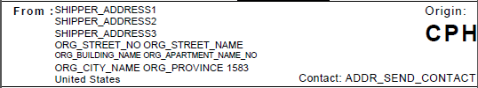

Example visual mapping of the receiver address fields on the label:

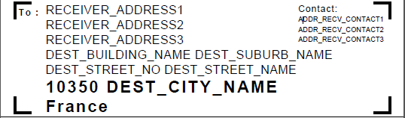

## Return Values

There are no additional returned values for this style of request. Please refer to the return values of section 6.6 and 6.7 for an overview.

# Additional COMMAND ATTRIBUTES

On top of the common COMMAND attributes already used (DATA_RETURN, LOOKUP, SHIPPER and RECEIVER_ADDRESS_MAPPING) there are other attributes, which can get used.

|  |  |  |  |  |
| --- | --- | --- | --- | --- |
| **Section / Field** | **Mandatory /Optional** | **Value constraints** | **Comments** | **Example value** |
| **Command** | | | | |
| TOBSCO | O | 1 AN | Tobsco (temporary OB sort code):  Value = “Y”  To take in TOBSCO into consideration while doing OB Sort Code lookup result for LOOKUP option = Y, 3, or 6.  Value = “N”  No reference to TOBSCO (default) while doing OB Sort Code lookup. | N |
| DCS_LOOKUP | O | 1 AN | Destination Control Statement (DCS)  Value = “Y”  Label Request with DCS lookup  Value = “N”  Label Request without DCS lookup (default) | N |
| ENHANCED_MESSAGE | O | 1 AN | Value = “Y”  return new enhanced message in response message  Value = “N”  not return new enhanced message in response message (default) | N |

## Enhanced Message information (Informational/Warning/Error)

If enhanced messaging is enabled the response message will provide a more granular response status message.

Response if ENHANCED_MESSAGE = N:  
*<Message Category="Warning" Description="Outbound sort code is not found."/>*

Response if ENHANCED_MESSAGE = Y:  
*<Message Category="Warning" Description="Outbound sort code is not found."/>  
 <RespStatus>  
 <Sev>30</Sev>  
 <MsgCIgd>GLS</MsgCIgd>  
 <MsgClg>340005</MsgClg>  
 <Dsc>Outbound sort code is not found.</Dsc>  
 <DtlDsc>Mismatch of origin country code, origin service area code, origin facility code, destination country code, destination service area code, destination facility code, product content code, shipment calendar date with DHL's specifications. Please provide data in accordance with DHL's specifications.</DtlDsc>  
 </RespStatus>  
 <RespStatus>  
 <Sev>10</Sev>  
 <MsgCIgd>GLS</MsgCIgd>  
 <MsgClg>100102</MsgClg>  
 <Dsc>Service operation execution finished with warning.</Dsc>  
 <DtlDsc>Service operation execution finished with warning.</DtlDsc>  
 </RespStatus>*

The new *RespStatus* segment can consists of the following attributes:

|  |  |  |  |  |
| --- | --- | --- | --- | --- |
| **Section / Field** | **Mandatory /Optional** | **Value constraints** | **Comments** | **Example** |
| Sev | Y | 2 N | Two-digit severity code  00 – Unknown 10 – for informational message 20 – for harmless but let user to decide type message 30 – for warning message 40 – for minor error message 50 – for critical error message 60 – for fatal error message  Note:   * Severity code 10 will be used to report the status of response in addition to current response status to align with standard message implementations. The message in this severity code will always returned as first message in the message list. * Severity code 30 will be used to report all the current warning messages returned * Severity code 40 is reserved for future usage (e.g. : partial result) * Severity code 50 will be used to report all the current error messages returned | 10 |
| MsgClg | Y | 6 N | Service-specific error code  6-digit structural error code to be used (to align with current error code standard format)  The following error code structures will be use: {A}{B}{CCCC}  Where  A – 1-digit error/warning category code  B – 1-digit error/warning subcategory code  CCCC - 4-digit detailed error/warning code | 100102 |
| MsgCIgd | Y |  | Error message catalogue code. Default to GLS for Document Based Services | GLS |
| Dsc | Y | 128 AN | Short message description. | *Service operation execution finished with warning* |
| DtlDsc | Y | 1024 AN | More detail message description | *Mismatch of origin country code, origin service area code, origin facility code, destination country code, destination service area code, destination facility code, product content code, shipment calendar date with DHL’s specifications. Please provide data in accordance with DHL's specifications* |
| BOErr | N |  | Identification of business object. |  |
| BOErr/FldErr | Y |  | Field Error |  |
| BOErr/FldErr/FldId | N |  | Identification of field |  |
| BOErr/FldErr/FldOrgVal | N |  | Field original value as used for the validation. |  |
| BOErr/FldErr/FldOrgVal/FldNm | N |  | Name of field |  |
| BOErr/FldErr/FldOrgVal/FldXPth | N |  | XPath to Field |  |

# Scenario 3 – Generating commercial invoices

There are various templates to create a commercial invoice, which is needed for dutiable shipments. Below you find a super set of attributes, which can be used across the templates.

After that table you find a mapping of attributes to the templates from which you can see, which attributes can be used for which template.

## Input Values

|  |  |  |  |  |
| --- | --- | --- | --- | --- |
| **Section / Field** | **Mandatory / Optional** | **Value Constraint** | **Comment** | **Example Value** |
| AWB_NO | O | 35 | Shipment Id | 12345676891 |
| SHIPMENT_ID | O | 35 | Shipment Id | 1234567689 |
| SHIPMENT_ID_CHECK_DIGIT | O | 2 | Shipment Id Check Digit | 1 |
| ADDR_SEND_NAME1 | O | 45 | Shipper Address Name1/ Country specific information (IBTI -CA specific) | XYZ Company |
| ADDR_SEND_NAME2 | O | 45 | Shipper Address Name2/ Country specific information (IBTI -CA specific) | 28 Bright Street |
| ADDR_SEND_NAME3 | O | 45 | Shipper Address Name3/ Country specific information (IBTI -CA specific) | 88000 Kota Kinabalu |
| ADDR_SEND_NAME4 | O | 45 | Shipper Address Name4 | Sabah |
| ADDR_SEND_NAME5 | O | 45 | Shipper Address Name5 | Malaysia |
| ADDR_SEND_NAME6 | O | 45 | Shipper Address Name6 |  |
| ADDR_SEND_NAME7 | O | 45 | Shipper Address Name7 |  |
| ADDR_SEND_CONTACT1 | O | 30 | Shipper Contact Line1 (IBTI -EU specific) | Phone: +52743432 |
| ADDR_SEND_CONTACT2 | O | 30 | Shipper Contact Line2 (IBTI -EU specific) | Fax: +529829438 |
| ADDR_SEND_CONTACT3 | O | 30 | Shipper Contact Line3 (IBTI -EU specific) | John Smith |
| ADDR_RECV_NAME1 | M | 45 | Receiver Address Name1 | ABC Company |
| ADDR_RECV_NAME2 | O | 45 | Receiver Address Name2 | Contact Center Research Dept. |
| ADDR_RECV_NAME3 | O | 45 | Receiver Address Name3 | 12 Happy Street |
| ADDR_RECV_NAME4 | O | 45 | Receiver Address Name4 | 10350 St Flavy |
| ADDR_RECV_NAME5 | O | 45 | Receiver Address Name5 | France |
| ADDR_RECV_NAME6 | O | 45 | Receiver Address Name6 |  |
| ADDR_RECV_NAME7 | O | 45 | Receiver Address Name7 |  |
| ADDR_RECV_CONTACT1 | O | 30 | Receiver Contact Line1 | Mr. Hills |
| ADDR_RECV_CONTACT2 | O | 30 | Receiver Contact Line2 | s.hills@recalls.com |
| ADDR_RECV_CONTACT3 | O | 30 | Receiver Contact Line3 | 0206 920 8765 |
| INV_NUMBER | O | 30 | Invoice Number | 2389830283924 |
| INV_DATE | M | 11 | Invoice Date | 10.01.2019 |
| SHIPMENT_REFNO | O | 30 | Shipment Reference | 0248920438 |
| ADDR_SEND_VATNO | O | 30 | Sender VAT No. | MY2394892349234 |
| ADDR_RECV_VATNO | O | 30 | Receiver VAT No. (IBTI -EU specific) | FR232834920943 |
| SHIPMENT_EXP_TYPE | O | 30 | Type of Export | Permanent Export |
| SHIPMENT_EXP_REAS | O | 30 | Reason for Export | Under Warranty |
| SHIPMENT_EXP_CURR | O | 30 | Currency Code | EUR |
| SHIPMENT_EXP_TOT | O | 30 | Terms of Trade | Ex Works |
| SHIPMENT_EXP_ORIG | O | 30 | Product Origin | Germany |
| SHIPMENT_DRYICE | O | 30 | Dry Ice Weight | 4.5 |
| INVLINE_DESCR1…n | O | 50 | Full Description of Goods | Laptop |
| INVLINE_QTY1…n | O | 5 | Quantity | 1 |
| INVLINE_UNITVAL1…n | O | 15 | Unit Value | 300.00 |
| INVLINE_SUBTOTAL1…n | O | 15 | Subtotal Value | 300.00 |
| INVLINE_UNITWEIGHT1…n | O | 15 | Unit Net Weight | 3.74 |
| INVLINE_ORIGIN1…n | O | 30 | Country of Manufacture / Origin | DE |
| INVLINE_COMMCODE1…n | O | 20 | Comm. Code | 123456 |
| INVLINE_SUBTOTALVAL1 | O | 15 | Subtotal Value | 12.42 |
| INVLINE_GROSSWEIGHT1 | O | 15 | Gross Weight | 3.1 |
| INVLINE_NETWEIGHT1 | O | 15 | Net Weight | 2.93 |
| INVTOTAL_DECLVAL | O | 15 | Total Declared Value | 300.00 |
| INVTOTAL_QTY | O | 5 | Total Quantity | 1 |
| INVTOTAL_NETWEIGHT | O | 15 | Total Net Weight | 3.74 |
| INVTOTAL_GROSSWEIGHT | O | 15 | Total Gross Weight | 4.1 |
| SHIPMENT_SPECIAL_SERVICES | O |  | Additional Declaration from customer as required, multi-line field | This is my special requirement |
| COMP_LOGO_Base64 | O |  | Digital signature Image can get uploaded | Base64 String representation of the image |
|  |  |  |  |  |
| DTP | O |  | Terms of Trade |  |
| EXP_REASON | O |  | Export Reason |  |
| EXP_TYPE | O |  | Type of Export |  |
| INFO_EN | O |  | Information Text English |  |
| INFO_ES | O |  | Information Test Spanish |  |

|  |  |  |  |  |
| --- | --- | --- | --- | --- |
| **Field Name** | **CUST_INV_A4_001** | **COMMERCIAL_INVOICE_01** | **COMMERCIAL_INVOICE_02** | **COMMERCIAL_INVOICE_03** |
| SHIPMENT_ID | X |  |  |  |
| SHIPMENT_ID_CHECK_DIGIT | X |  |  |  |
| ADDR_SEND_NAME1 | X | X | X |  |
| ADDR_SEND_NAME2 | X | X | X |  |
| ADDR_SEND_NAME3 | X | X | X |  |
| ADDR_SEND_NAME4 | X | X | X |  |
| ADDR_SEND_NAME5 | X | X | X |  |
| ADDR_SEND_NAME6 | X | X | X |  |
| ADDR_SEND_NAME7 | X | X | X |  |
| ADDR_RECV_NAME1 | X | X | X |  |
| ADDR_RECV_NAME2 | X | X | X |  |
| ADDR_RECV_NAME3 | X | X | X |  |
| ADDR_RECV_NAME4 | X | X | X |  |
| ADDR_RECV_NAME5 | X | X | X |  |
| ADDR_RECV_NAME6 | X | X | X |  |
| ADDR_RECV_NAME7 | X | X | X |  |
| ADDR_RECV_CONTACT1 | X | X | X |  |
| ADDR_RECV_CONTACT2 | X | X | X |  |
| ADDR_RECV_CONTACT3 | X |  |  |  |
| ADDR_SEND_CONTACT1 | X | X | X |  |
| ADDR_SEND_CONTACT2 | X | X | X |  |
| ADDR_SEND_CONTACT3 | X |  |  |  |
| INV_NUMBER | X |  |  |  |
| INV_DATE | X | X | X |  |
| SHIPMENT_REFNO | X |  |  |  |
| ADDR_SEND_VATNO | X | X | X |  |
| ADDR_RECV_VATNO | X | X | X |  |
| SHIPMENT_EXP_TYPE | X |  |  |  |
| SHIPMENT_EXP_REAS | X |  |  |  |
| SHIPMENT_EXP_CURR | X |  |  |  |
| SHIPMENT_EXP_TOT | X |  |  |  |
| SHIPMENT_EXP_ORIG | X |  |  |  |
| SHIPMENT_DRYICE | X |  |  |  |
| INVLINE_DESCR1…n | X | X | X |  |
| INVLINE_QTY1…n | X | X | X |  |
| INVLINE_UNITVAL1…n | X | X | X |  |
| INVLINE_SUBTOTAL1…n | X |  |  |  |
| INVLINE_UNITWEIGHT1…n | X |  |  |  |
| INVLINE_ORIGIN1…n | X | X | X |  |
| INVLINE_COMMCODE1…n | X | X | X |  |
| INVLINE_SUBTOTALVAL1-8 |  | X | X |  |
| INVTOTAL_DECLVAL | X |  |  |  |
| INVTOTAL_QTY | X |  |  |  |
| INVTOTAL_NETWEIGHT | X |  |  |  |
| INVTOTAL_GROSSWEIGHT | X |  |  |  |
| SHIPMENT_SPECIAL_SERVICES | X |  |  |  |
| COMP_LOGO_Base64 | X |  |  |  |
| DTP |  | X | X |  |
| EXP_REASON |  | X | X |  |
| EXP_TYPE |  | X | X |  |
| INFO_EN |  | X | X |  |
| INFO_ES |  | X | X |  |
| AWB_NO |  | X | X |  |
| SHIPMENT_DRYICE | X |  |  |  |

## Return Values

There are no additional returned values for this style of request. Please refer to the return values of section 6.6 and 6.7 for an overview.

# Appendix A: Label Formats and Section Guide

## 10x21CM (4x8”) Label Format

The default labels size is 10x21cm (or 4x8”). Underneath you will find an example label including a customer logo, customer barcode and the Waybill Doc (which is used for billing and customs purposes by DHL Express). The available templates to use for this size are:

* ECOM26_84_001 (default transport label)
* ECOM26_84CI_002 (for use with a customer barcode on transport label)
* ARCH_8X4 (to be used for the Waybill Doc only)

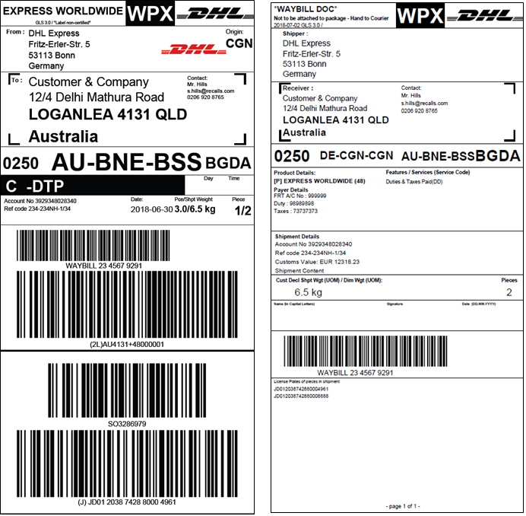

## 10x15CM (4x6”) Label Format

Using 10x15cm (or 4x6”) as label size is also possible within GLS. Underneath you will see the exact same labels as in section 9.1, rendered at size 10x15cm (4x6”). Please note the use of a customer logo is still possible whereas the use of a customer barcode at this size is **not** possible.

The available template to use for this size is:

* ECOM26_64_001 (transport label)
* ARCH_6X4 (Waybill Doc)

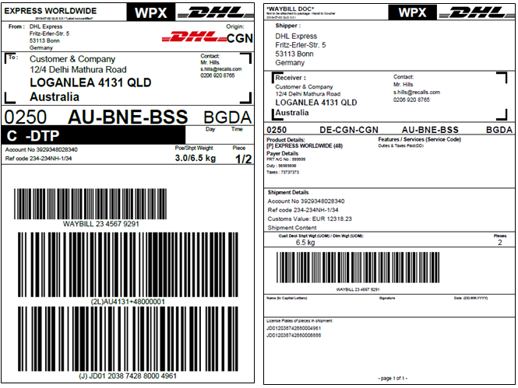

## A4 Label Format

Using A4 as label size is also possible within GLS. Underneath you will see the exact same transport label as in section 9.1 & 9.2, rendered at size A4. Please note the use of a customer logo is still possible whereas the use of a customer barcode at this size is **not** possible. This does include additional instructions for the shipper.  
  
The Waybill Doc is rendered at 10x21xm (8x4”) but made available on A4 size for printing. There’s no difference in layout compared to the regular 10x21cm template.

The available template to use for this size is:

* ECOM26_A4_001 (transport label)
* ARCH_8X4_A4 (Waybill Doc)

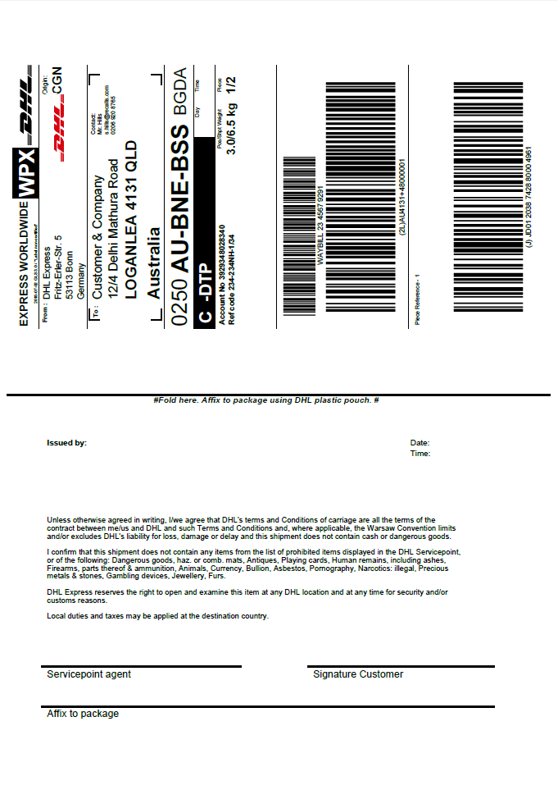

## Label Layout & Section guide

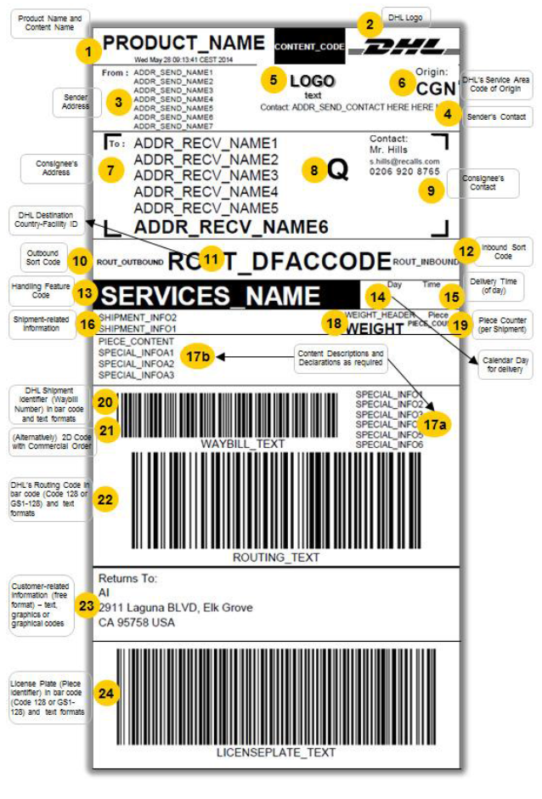

# Appendix B: Invoice Formats

## COMMERCIAL_INVOICE_01

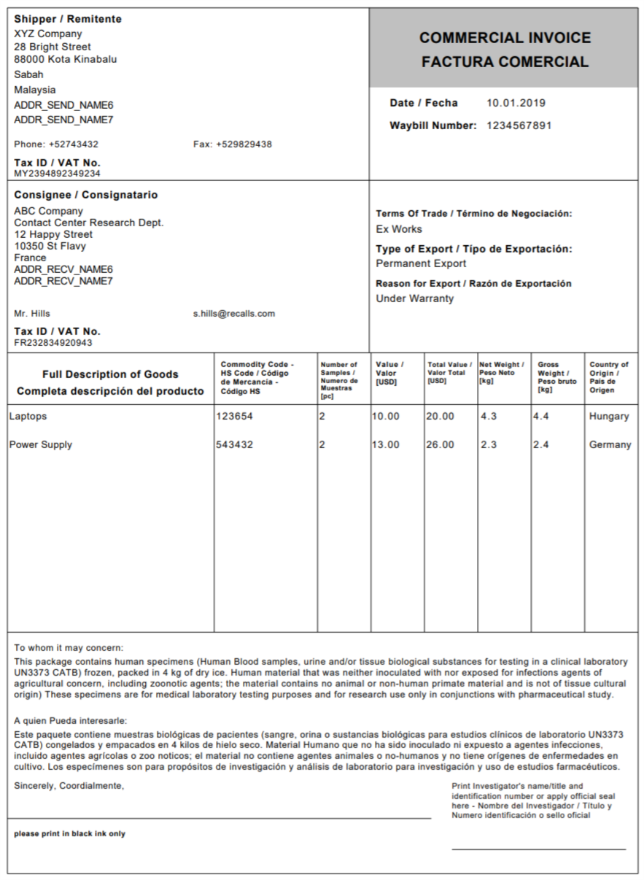

## CUST_INV_A4_001

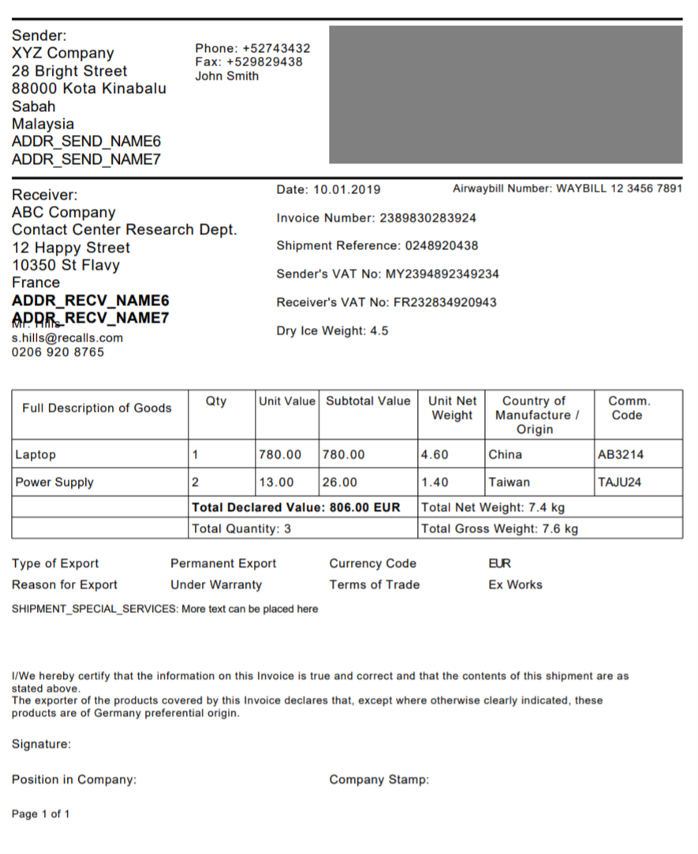

# Appendix C: Code Samples

## Full Data Lookup

<soapenv:Envelope xmlns:soapenv="http://schemas.xmlsoap.org/soap/envelope/" xmlns:gls="http://www.dhl.com/GLS/GLSDoc">

<soapenv:Header/>

<soapenv:Body>

<gls:GLSDocRequest

xsi:schemaLocation="http://www.dhl.com/GLS/GLSDoc GLSDoc.xsd"

xmlns:gls="http://www.dhl.com/GLS/GLSDoc"

xmlns:xsi="http://www.w3.org/2001/XMLSchema-instance">

<Hdr Ver="1.0" No="1" Dtm="2018-06-30T09:30:47.0Z" GmtOff="1.0">

<Sndr />

</Hdr>

<Command>

<Field Name="LOOKUP" Value="3"/>

</Command>

<Data>

<Field Name="ORG_COUNTRY_CODE" Value="GB" />

<Field Name="ORG_POSTCODE" Value="TW4 6JS" />

<Field Name="ORG_CITY_NAME" Value="Hounslow" />

<Field Name="DEST_COUNTRY_CODE" Value="AU" />

<Field Name="DEST_POSTCODE" Value="4131" />

<Field Name="DEST_CITY_NAME" Value="LOGANLEA" />

<Field Name="NETWORK_PRODUCT_CODE" Value="E" />

<Field Name="SHIPMENT_CALENDAR_DATE" Value="2018-06-30" />

<FieldList Name="SERVICE" >

<Map>

<Entry Key="GLOBAL_SERVICE_CODE" Value="DD" />

</Map>

</FieldList>

</Data>

</gls:GLSDocRequest>

</soapenv:Body>

</soapenv:Envelope>

## Data Lookup and Label Render, no address mapping

### Data Lookup and Label Render, no address mapping

<soapenv:Envelope xmlns:soapenv="http://schemas.xmlsoap.org/soap/envelope/">

<soapenv:Header/>

<soapenv:Body>

<gls:GLSDocRequest xmlns:gls="http://www.dhl.com/GLS/GLSDoc">

<Hdr Ver="1.0" No="1" Dtm="2018-06-30T09:30:47.0Z" GmtOff="2.0">

<Sndr/>

</Hdr>

<Command>

<Field Name="LOOKUP" Value="Y"/>

<Field Name="DATA_RETURN" Value="Y"/>

<Field Name="SHIPPER_ADDRESS_MAPPING" Value="N"/>

<Field Name="RECEIVER_ADDRESS_MAPPING" Value="N"/>

</Command>

<Data>

<!--Renderer information-->

<Field Name="APPLICATION_CODE" Value="MY Customer APP"/>

<Field Name="APPLICATION_VERSION" Value="2.1"/>

<Field Name="CERTIFICATION_IDENTIFIER" Value="00-000000"/>

<!--Fields used for lookup.-->

<Field Name="ORG_COUNTRY_CODE" Value="DE"/>

<Field Name="ORG_POSTCODE" Value="53113"/>

<Field Name="DEST_COUNTRY_CODE" Value="AU"/>

<Field Name="DEST_POSTCODE" Value="4131"/>

<Field Name="NETWORK_PRODUCT_CODE" Value="P"/>

<Field Name="SHIPMENT_CALENDAR_DATE" Value="2018-06-30"/>

<!--Sender Address information - additional to lookup fields above.-->

<Field Name="ADDR_SEND_NAME1" Value="DHL Express"/>

<Field Name="ADDR_SEND_NAME3" Value="Fritz-Erler-Str. 5"/>

<Field Name="ADDR_SEND_NAME6" Value="53113 Bonn"/>

<Field Name="ADDR_SEND_NAME7" Value="Germany"/>

<Field Name="ADDR_SEND_CONTACT" Value="Contact: Mr. Contact +32678944574814"/>

<!--Receiver Address information - additional to lookup fields above.-->

<Field Name="ADDR_RECV_NAME1" Value="Customer &amp; Company"/>

<Field Name="ADDR_RECV_NAME2" Value="Delhi Mathura Road"/>

<Field Name="ADDR_RECV_NAME3" Value="12/4"/>

<Field Name="ADDR_RECV_NAME3" Value="4131 QLD"/>

<Field Name="ADDR_RECV_NAME5" Value="LOGANLEA"/>

<Field Name="ADDR_RECV_NAME7" Value="Australia"/>

<!--Receiver contact details.-->

<Field Name="ADDR_RECV_CONTACT1" Value="Mr. Hills"/>

<Field Name="ADDR_RECV_CONTACT2" Value="s.hills@recalls.com"/>

<Field Name="ADDR_RECV_CONTACT3" Value="0206 920 8765"/>

<!--Payment details.-->

<Field Name="PAYMENT_CODE" Value="Y"/>

<Field Name="FRT_ACCOUNT_NO" Value="FRT A/C No : 999999"/>

<Field Name="DUTY_ACCOUNT_NO" Value="Duty : 98989898"/>

<Field Name="TAXES_ACCOUNT_NO" Value="Taxes : 73737373"/>

<Field Name="DHL_LOGO_FLAG" Value="Y"/>

<!--Shipment information.-->

<Field Name="SHIPMENT_INFO1" Value="Ref code 234-234NH-1/34"/>

<Field Name="SHIPMENT_INFO2" Value="Account No 3929348028340"/>

<Field Name="SHIPMENT_INFO3" Value="Customs Value: EUR 12318.23"/>

<Field Name="PICKUP_DATE" Value="2018-06-30"/>

<Field Name="SHIPMENT_WEIGHT" Value="6.5"/>

<Field Name="WEIGHT_UOM" Value="kg"/>

<Field Name="TOTAL_NO_OF_PIECES" Value="2"/>

<Field Name="PIECE_CONTENT" Value="Shipment Content Test Contents"/>

<!--Shipment ID & Symbology.-->

<Field Name="SHIPMENT_ID" Value="234567929"/>

<Field Name="SHIPMENT_ID_CHECK_DIGIT" Value="1"/>

<Field Name="SHIPMENT_ID_SYMBOLOGY" Value="]A0"/>

<Field Name="ROUTING_CODE_DATA_INDENTIFIER" Value="2L"/>

<Field Name="ROUTING_CODE_SYMBOLOGY" Value="]C0"/>

<!--Non DG VAS information.-->

<FieldList Name="SERVICE">

<Map>

<Entry Key="GLOBAL_SERVICE_CODE" Value="DD"/>

</Map>

</FieldList>

<!--DG information.-->

<FieldList Name="DANGEROUS_GOODS">

<Map>

<Entry Key="DNG_GDS_CNTN_ID" Value="901"/>

<Entry Key="DNG_GDS_UOM" Value="kg"/>

<Entry Key="DNG_GDS_NET_WGT" Value="5"/>

</Map>

</FieldList>

</Data>

<Document OutputFormat="PDF">

<Template Type="ECOM" TemplateId="ECOM26_84_001">

<Data>

<Field Name="PIECE_LP" Value="JD012038742880004961"/>

<Field Name="PIECE_LP_DATA_IDENTIFIER" Value="J"/>

<Field Name="PIECE_LP_SYMBOLOGY" Value="]C0"/>

<Field Name="PIECE_SEQ" Value="1"/>

<Field Name="PIECE_WEIGHT" Value="3.0"/>

<Field Name="PIECE_REFERENCE" Value="Piece Reference - 1"/>

</Data>

</Template>

<Template Type="ECOM" TemplateId="ECOM26_84_001">

<Data>

<Field Name="PIECE_LP" Value="JD012038742880008888"/>

<Field Name="PIECE_LP_DATA_IDENTIFIER" Value="2J"/>

<Field Name="PIECE_LP_SYMBOLOGY" Value="]C0"/>

<Field Name="PIECE_SEQ" Value="2"/>

<Field Name="PIECE_WEIGHT" Value="3.5"/>

<Field Name="PIECE_REFERENCE" Value="Piece Reference - 2"/>

</Data>

</Template>

</Document>

<Document OutputFormat="PDF">

<Template Type="ARCH" TemplateId="ARCH_8X4">

<Data>

<FieldList Name="PIECE_LP_ARCH_LIST">

<Map>

<Entry Key="PIECE_LP" Value="JD012038742880004961"/>

</Map>

<Map>

<Entry Key="PIECE_LP" Value="JD012038742880008888"/>

</Map>

</FieldList>

</Data>

</Template>

</Document>

</gls:GLSDocRequest>

</soapenv:Body>

</soapenv:Envelope>

### Customer Logo and Barcode

The underneath code can be added to the <Data> section of the request in section 10.2.1 to make use of the customer section on the label. This will allow you to add in your own logo & barcode to the DHL transport label.  
  
To add a customer logo to the label use the below code. The logo will appear in the FROM: section on the label where the shipper address is displayed. The underneath code will add a DHL logo to the label. Please provide a base 64 encoded version of the logo you wish to include:

<Field Name="SEND_LOGO_BASE64" Value="iVBORw0KGgoAAAANSUhEUgAAAI4AAAAUCAMAAABs3vUfAAAAOVBMVEX////WBBHWBBHWBBHW  
BBHWBBHWBBHWBBHWBBHWBBHWBBHWBBHWBBHWBBHWBBHWBBHWBBHWBBHWBBHVxcxSAAAAEnRSTlMAECAwQFBgZHCAkKCwwNDW4PCerd/RAAABSk  
lEQVR4Xr3WAU7EIBCF4TdAEVqmlrn/YY0xUZZnQZLG7wBkF/4O4EawIY34UaxRHQBkayUAaq1TsEKqTej3gslaG/+ZQr+veixRm1J88dbaAcBV  
a1xCmx2xJNsNXlMuPoTTWp42+8DASji8aOFDOJ4Lh/Z6clqZNyw+HI6EO+k1E2pCPz0SDpPcSFy4oyZYHYSzqPR7jsRNTMT1cBiPkyoAfB9y/k  
vtO4WzisfJ1n+/J4fDTgG2Z8K5eLhpwwPYdcIBUrS1PxGOCf6LMVMkG0p0VQUACNraAGQdkj4/KCvijQ3DSeD7Al04LMHpKwQGuSaF9sOk8AHX  
+VgqPHBhZEexkUP6W/Jdfn9oBBu5RE7rIPfSOJy6oR8m9Y0nwzG/ij187oHCwSicmgXURLx7aECH4QQlsI4fhFOigK/8/e6hASAe1204rhr5AC  
/2dTzSdVQhAAAAAElFTkSuQmCC" />

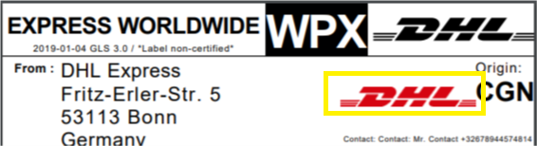

To include a customer barcode on the label, please use the below code. The customer barcode will appear below the DHL Express routing barcode.

<Field Value="128" Name="CUSTOMER_BARCODE_TYPE"/>

<Field Value="My Cust Barcode" Name="CUSTOMER_BARCODE_CODE"/>

<Field Value="My Cust Barcode" Name="CUSTOMER_BARCODE_TEXT"/>

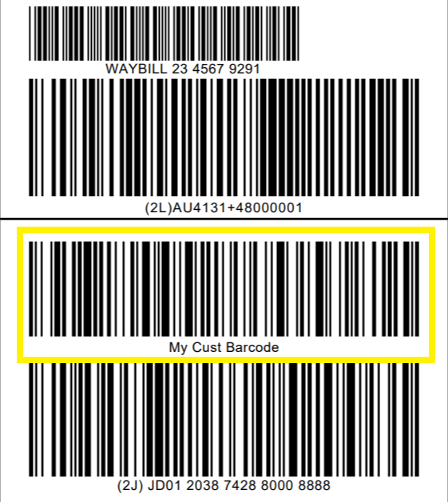

As mentioned in section 6.2, please ensure the TemplateID for the Transport Label is set to “ECOM26_84CI_002”. This is currently the only template that supports an additional customer barcode.

### Dangerous Goods

The underneath code can be added to the <Data> section of the request in section 10.2.1 to create a label that contains all IATA required information for a Dangerous Goods shipment. In case multiple types of DG are present in a shipment (for example Dry Ice & Biological Substances), please add each DG type within the DANGEROUS_GOODS FieldList, but each in their own Map.  
  
For Dry Ice shipments, use below code:

<FieldList Name="DANGEROUS_GOODS">

<Map>

<Entry Key="DNG_GDS_CNTN_ID" Value="901"/>

<Entry Key="DNG_GDS_UOM" Value="kg"/>

<Entry Key="DNG_GDS_NET_WGT" Value="5"/>

</Map>

</FieldList>

For Excepted Quantities shipments, you have to specify the ContentID as well as the UN Code as follows:

<FieldList Name="DANGEROUS_GOODS">

<Map>

<Entry Key="DNG_GDS_CNTN_ID" Value="E01"/>

<Entry Key="DNG_GDS_UN_CD" Value="1189"/>

</Map>

</FieldList>  
  
For other types of Dangerous Goods, you can use the following during lookup (where the value would be the ContentID of the requested type of Dangerous Goods:

<FieldList Name="DANGEROUS_GOODS">

<Map>

<Entry Key="DNG_GDS_CNTN_ID" Value="966"/>

</Map>

</FieldList>

Please refer to the embedded file in chapter 13. Appendix E: DHL Reference Data, sheet “dangerous goods” for a full overview of ContentID’s and Charge Codes for Dangerous Goods shipments.

A shipment with both Dry Ice and Biological Substances (UN3373) would have the following Dangerous Goods FieldList in the <Data> section of the request:

<FieldList Name="DANGEROUS_GOODS">

<Map>

<Entry Key="DNG_GDS_CNTN_ID" Value="901"/>

<Entry Key="DNG_GDS_UOM" Value="kg"/>

<Entry Key="DNG_GDS_NET_WGT" Value="5"/>

</Map>

<Map>

<Entry Key="DNG_GDS_CNTN_ID" Value="650"/>

</Map>

</FieldList>

The above would result in the following label & Waybill Doc:

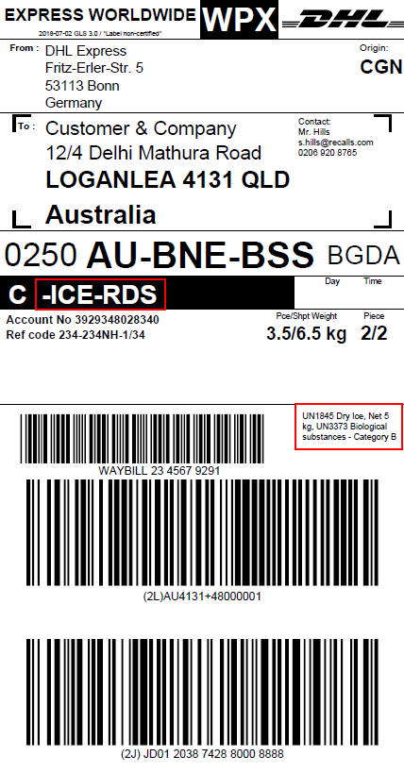 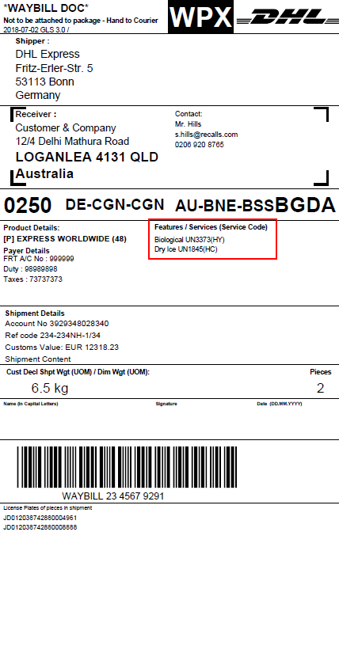

## Data Lookup and Label Render, with address mapping

The code for this request is identical to the code in section 10.2.1, apart from the shipper & receiver address sections. Therefore, only the changed code has been listed below. Keep the request as it is in 10.2.1 (including the fields used for lookup) and only change out the Sender address information and Receiver address information with the code listed below.

Also, set SHIPPER_ADDRESS_MAPPING and RECEIVER_ADDRESS_MAPPING to “Y” in the command section of the request (on 10.2.1 they were both set to “N” as no address mapping was being used).

<!-- Sender Address information - additional to lookup fields above. -->

<Field Name="SHIPPER_ADDRESS1" Value="DHL Express" />

<Field Name="ORG_STREET_NAME" Value="Fritz-Erler-Str." />

<Field Name="ORG_STREET_NO" Value="5" />

<Field Name="ORG_CITY_NAME" Value="Bonn" />

<!-- Receiver Address information - additional to lookup fields above. -->

<Field Name="RECEIVER_ADDRESS1" Value="Customer &amp; Company" />

<Field Name="DEST_STREET_NAME" Value="Delhi Mathura Road" />

<Field Name="DEST_STREET_NO" Value="12/4" />

<Field Name="DEST_CITY_NAME" Value="LOGANLEA" />

<Field Name="DEST_PROVINCE" Value="QLD" />

For different countries the postal locations type might differ as e.g. no zip code is used in the country. Therefore, the address needs to fill different fields in the address mapping mode.

1. Countries with Zip code and city  
    <Field Name="ORG_COUNTRY_CODE" Value="DE"/>

<Field Name="ORG_POSTCODE" Value="53113"/>

<Field Name="ORG_CITY_NAME" Value="BONN"/>

1. Countries with city and suburb  
    <Field Name="ORG_COUNTRY_CODE" Value="IE"/>

<Field Name="ORG_CITY_NAME" Value="DUBLIN"/>

<Field Name="ORG_SUBURB_NAME " Value="ADELAIDE ROAD"/>

1. Countries with city only  
    <Field Name="ORG_COUNTRY_CODE" Value="HK"/>

<Field Name="ORG_CITY_NAME" Value="FAIRVIEW PARK"/>

This applies to both origin and destination addresses.

## Invoice COMMERCIAL_INVOICE_01

<soapenv:Envelope xmlns:soapenv="http://schemas.xmlsoap.org/soap/envelope/">

<soapenv:Header/>

<soapenv:Body>

<gls:GLSDocRequest xmlns:gls="http://www.dhl.com/GLS/GLSDoc">

<Hdr Ver="1.0" No="1" Dtm="2018-06-30T09:30:47.0Z" GmtOff="2.0">

<Sndr/>

</Hdr>

<Command>

<Field Name="LOOKUP" Value="N"/>

<Field Name="DATA_RETURN" Value="N"/>

<Field Name="SHIPPER_ADDRESS_MAPPING" Value="N"/>

<Field Name="RECEIVER_ADDRESS_MAPPING" Value="N"/>

</Command>

<Data>

<!--Sender Address information-->

<Field Name="ADDR_SEND_NAME1" Value="XYZ Company"/>

<Field Name="ADDR_SEND_NAME2" Value="28 Bright Street"/>

<Field Name="ADDR_SEND_NAME3" Value="88000 Kota Kinabalu"/>

<Field Name="ADDR_SEND_NAME4" Value="Sabah"/>

<Field Name="ADDR_SEND_NAME5" Value="Malaysia"/>

<Field Name="ADDR_SEND_NAME6" Value="ADDR_SEND_NAME6"/>

<Field Name="ADDR_SEND_NAME7" Value="ADDR_SEND_NAME7"/>

<Field Name="ADDR_SEND_CONTACT1" Value="Phone: +52743432"/>

<Field Name="ADDR_SEND_CONTACT2" Value="Fax: +529829438"/>

<Field Name="ADDR_SEND_VATNO" Value="MY2394892349234"/>

<!--Receiver Address information-->

<Field Name="ADDR_RECV_NAME1" Value="ABC Company"/>

<Field Name="ADDR_RECV_NAME2" Value="Contact Center Research Dept."/>

<Field Name="ADDR_RECV_NAME3" Value="12 Happy Street"/>

<Field Name="ADDR_RECV_NAME4" Value="10350 St Flavy"/>

<Field Name="ADDR_RECV_NAME5" Value="France"/>

<Field Name="ADDR_RECV_NAME6" Value="ADDR_RECV_NAME6"/>

<Field Name="ADDR_RECV_NAME7" Value="ADDR_RECV_NAME7"/>

<Field Name="ADDR_RECV_CONTACT1" Value="Mr. Hills"/>

<Field Name="ADDR_RECV_CONTACT2" Value="s.hills@recalls.com"/>

<Field Name="ADDR_RECV_VATNO" Value="FR232834920943"/>

<!--Invoice Information-->

<Field Name="INV_DATE" Value="10.01.2019"/>

<Field Name="AWB_NO" Value="1234567891"/>

<Field Name="DTP" Value="Ex Works"/>

<Field Name="EXP_REASON" Value="Under Warranty"/>

<Field Name="EXP_TYPE" Value="Permanent Export"/>

<!--Invoice Items Line 1-->

<Field Name="INVLINE_DESCR1" Value="Laptops"/>

<Field Name="INVLINE_COMMCODE1" Value="123654"/>

<Field Name="INVLINE_QTY1" Value="2"/>

<Field Name="INVLINE_UNITVAL1" Value="10.00"/>

<Field Name="INVLINE_SUBTOTALVAL1" Value="20.00"/>

<Field Name="INVLINE_UNITWEIGHT1" Value="4.00"/>

<Field Name="INVLINE_NETWEIGHT1" Value="4.3"/>

<Field Name="INVLINE_GROSSWEIGHT1" Value="4.4"/>

<Field Name="INVLINE_ORIGIN1" Value="Hungary"/>

<!--Invoice Items Line 2-->

<Field Name="INVLINE_DESCR2" Value="Power Supply"/>

<Field Name="INVLINE_COMMCODE2" Value="543432"/>

<Field Name="INVLINE_QTY2" Value="2"/>

<Field Name="INVLINE_UNITVAL2" Value="13.00"/>

<Field Name="INVLINE_SUBTOTALVAL2" Value="26.00"/>

<Field Name="INVLINE_UNITWEIGHT2" Value="2.00"/>

<Field Name="INVLINE_NETWEIGHT2" Value="2.3"/>

<Field Name="INVLINE_GROSSWEIGHT2" Value="2.4"/>

<Field Name="INVLINE_ORIGIN2" Value="Germany"/>

<!--Predefined text, which can get overridden-->

<!--<Field Name="INFO_EN" Value="INFO TEXT ENGLISH"/>

<Field Name="INFO_ES" Value="INFO TEXT SPANISH"/>-->

</Data>

<Document OutputFormat="PDF">

<Template Type="PFIV" TemplateId="COMMERCIAL_INVOICE_01"/>

</Document>

</gls:GLSDocRequest>

</soapenv:Body>

</soapenv:Envelope>

## Invoice CUST_INV_A4_001

<soapenv:Envelope xmlns:soapenv="http://schemas.xmlsoap.org/soap/envelope/">

<soapenv:Header/>

<soapenv:Body>

<gls:GLSDocRequest xmlns:gls="http://www.dhl.com/GLS/GLSDoc">

<Hdr Ver="1.0" No="1" Dtm="2018-06-30T09:30:47.0Z" GmtOff="2.0">

<Sndr/>

</Hdr>

<Command>

<Field Name="LOOKUP" Value="N"/>

<Field Name="DATA_RETURN" Value="N"/>

<Field Name="SHIPPER_ADDRESS_MAPPING" Value="N"/>

<Field Name="RECEIVER_ADDRESS_MAPPING" Value="N"/>

</Command>

<Data>

<!--Sender Address information-->

<Field Name="ADDR_SEND_NAME1" Value="XYZ Company"/>

<Field Name="ADDR_SEND_NAME2" Value="28 Bright Street"/>

<Field Name="ADDR_SEND_NAME3" Value="88000 Kota Kinabalu"/>

<Field Name="ADDR_SEND_NAME4" Value="Sabah"/>

<Field Name="ADDR_SEND_NAME5" Value="Malaysia"/>

<Field Name="ADDR_SEND_NAME6" Value="ADDR_SEND_NAME6"/>

<Field Name="ADDR_SEND_NAME7" Value="ADDR_SEND_NAME7"/>

<Field Name="ADDR_SEND_CONTACT1" Value="Phone: +52743432"/>

<Field Name="ADDR_SEND_CONTACT2" Value="Fax: +529829438"/>

<Field Name="ADDR_SEND_CONTACT3" Value="John Smith"/>

<!--Receiver Address information-->

<Field Name="ADDR_RECV_NAME1" Value="ABC Company"/>

<Field Name="ADDR_RECV_NAME2" Value="Contact Center Research Dept."/>

<Field Name="ADDR_RECV_NAME3" Value="12 Happy Street"/>

<Field Name="ADDR_RECV_NAME4" Value="10350 St Flavy"/>

<Field Name="ADDR_RECV_NAME5" Value="France"/>

<Field Name="ADDR_RECV_NAME6" Value="ADDR_RECV_NAME6"/>

<Field Name="ADDR_RECV_NAME7" Value="ADDR_RECV_NAME7"/>

<Field Name="ADDR_RECV_CONTACT1" Value="Mr. Hills"/>

<Field Name="ADDR_RECV_CONTACT2" Value="s.hills@recalls.com"/>

<Field Name="ADDR_RECV_CONTACT3" Value="0206 920 8765"/>

<!--Invoice information.-->

<Field Name="SHIPMENT_ID" Value="123456789"/>

<Field Name="SHIPMENT_ID_CHECK_DIGIT" Value="1"/>

<Field Name="WEIGHT_UOM" Value="KG"/>

<Field Name="INV_DATE" Value="10.01.2019"/>

<Field Name="INV_NUMBER" Value="2389830283924"/>

<Field Name="SHIPMENT_REFNO" Value="0248920438"/>

<Field Name="ADDR_SEND_VATNO" Value="MY2394892349234"/>

<Field Name="ADDR_RECV_VATNO" Value="FR232834920943"/>

<Field Name="SHIPMENT_DRYICE" Value="4.5"/>

<!--Invoice Items Line 1-->

<Field Name="INVLINE_DESCR1" Value="Laptop"/>

<Field Name="INVLINE_QTY1" Value="1"/>

<Field Name="INVLINE_UNITVAL1" Value="780.00"/>

<Field Name="INVLINE_SUBTOTAL1" Value="780.00"/>

<Field Name="INVLINE_UNITWEIGHT1" Value="4.60"/>

<Field Name="INVLINE_ORIGIN1" Value="China"/>

<Field Name="INVLINE_COMMCODE1" Value="AB3214"/>

<!--Invoice Items Line 2-->

<Field Name="INVLINE_DESCR2" Value="Power Supply"/>

<Field Name="INVLINE_QTY2" Value="2"/>

<Field Name="INVLINE_UNITVAL2" Value="13.00"/>

<Field Name="INVLINE_SUBTOTAL2" Value="26.00"/>

<Field Name="INVLINE_UNITWEIGHT2" Value="1.40"/>

<Field Name="INVLINE_ORIGIN2" Value="Taiwan"/>

<Field Name="INVLINE_COMMCODE2" Value="TAJU24"/>

<!--Invoice Totals-->

<Field Name="INVTOTAL_DECLVAL" Value="806.00 EUR"/>

<Field Name="INVTOTAL_QTY" Value="3"/>

<Field Name="INVTOTAL_NETWEIGHT" Value="7.4 kg"/>

<Field Name="INVTOTAL_GROSSWEIGHT" Value="7.6 kg"/>

<!--Invoice Information-->

<Field Name="SHIPMENT_EXP_REAS" Value="Under Warranty"/>

<Field Name="SHIPMENT_EXP_TYPE" Value="Permanent Export"/>

<Field Name="SHIPMENT_EXP_CURR" Value="EUR"/>

<Field Name="SHIPMENT_EXP_TOT" Value="Ex Works"/>

<Field Name="SHIPMENT_EXP_ORIG" Value="Germany"/>

<Field Name="SHIPMENT_SPECIAL_SERVICES" Value="SHIPMENT_SPECIAL_SERVICES: More text can be placed here"/>

</Data>

<Document OutputFormat="PDF">

<Template Type="PFIV" TemplateId="CUST_INV_A4_001"/>

</Document>

</gls:GLSDocRequest>

</soapenv:Body>

</soapenv:Envelope>

# Appendix D: License plates, Barcodes and Symbologies

A barcode (also bar code) is an optical, machine-readable representation of data; the data usually describes something about the object that carries the barcode. Traditional barcodes systematically represent data by varying the widths and spacings of parallel lines and may be referred to as linear or one-dimensional (1D).

The mapping between messages and barcodes is called a [symbology](https://en.wikipedia.org/wiki/Symbology). The specification of a symbology includes the encoding of the message into bars and spaces, any required start and stop markers, the size of the quiet zone required to be before and after the barcode, and the computation of a [checksum](https://en.wikipedia.org/wiki/Checksum).

([Source Wikipedia.org](https://en.wikipedia.org/wiki/Barcode#Symbologies)).

The various label templates can hold barcodes for multiple purposes requiring different symbologies as can be seen in the table below.

|  |  |  |  |  |
| --- | --- | --- | --- | --- |
| **Barcode on Label** | **Data Identifier** | **Barcode Types** | **Country Code** | **Symbology Identifier** |
| Waybill,  the shipment Identifier | none | [Code 39](https://en.wikipedia.org/wiki/Code_39) | n/a | ]A0 |
| Piece license plate,  the unique identifier of a piece | J, 1J, 2J, 3J, 4J, 5J, 6J | [Code 128](https://en.wikipedia.org/wiki/Code_128) | 2 char ISO3166 | ]C0 |
|  | 00 | [GS1-128](https://en.wikipedia.org/wiki/GS1-128) | 3 char ISO3166 | ]C1 |
| Routing Barcode,  information needed for DHL internal  routing / sorting | 2L | [Code 128](https://en.wikipedia.org/wiki/Code_128) | n/a | ]C0 |
| Customer Barcode,  information provided by the customer  e.g. Reference Number |  | Code 128 | n/a | Not needed |

For each use case you have a code example in the table below.

The data identifier for piece must be set according to the license plate you will use in the request message. Symbology and data identifier always must be matching as shown in the table above. The routing bar code will be automatically built from input attributes like destination country or zip code.

|  |  |
| --- | --- |
| **Barcode on Label** | **Example Request** |
| Waybill | <Field Name="SHIPMENT_ID" Value="906955985"/> <Field Name="SHIPMENT_ID_CHECK_DIGIT" Value="5"/> <Field Name="SHIPMENT_ID_SYMBOLOGY" Value="]A0"/> |
| License Plate | <Field Name="PIECE_LP" Value="JD014600003761632619"/> <Field Name="PIECE_LP_DATA_IDENTIFIER" Value="J"/> <Field Name="PIECE_LP_SYMBOLOGY" Value="]C0"/> |
|  |
| Routing Barcode | <Field Name="ROUTING_CODE_DATA_INDENTIFIER" Value="2L"/> <Field Name="ROUTING_CODE_SYMBOLOGY" Value="]C0"/> |
|  |
| Customer Barcode | <Field Value="128" Name="CUSTOMER_BARCODE_TYPE"/>  <Field Value="SO3286979" Name="CUSTOMER_BARCODE_CODE"/>  <Field Value="SO3286979" Name="CUSTOMER_BARCODE_TEXT"/> |

The below table holds a sample barcode for the sample requests in the table above.

|  |  |
| --- | --- |
| **Barcode on Label** | **Barcode Example** |
| Waybill |  |
| License Plate |  |
| Routing Barcode |  |
| Customer Barcode |  |

If you want to know more about license plates ISO standards and which license plates you can use with DHL, please refer to the attached document:



Examples for license plates and the respective request attributes:

|  |  |  |  |
| --- | --- | --- | --- |
| **License Plate** | **Data Identifier** | **Symbology** | **Request** |
| JJD0002930001000456 | J | ]C0 | <Field Name="PIECE_LP" Value="JD0002930001000456"/> <Field Name="PIECE_LP_DATA_IDENTIFIER" Value="J"/> <Field Name="PIECE_LP_SYMBOLOGY" Value="]C0"/> |
| 3JSIA1234567712345670001 | 3J | ]C0 | <Field Name="PIECE_LP" Value="SIA1234567712345670001"/> <Field Name="PIECE_LP_DATA_IDENTIFIER" Value="3J"/> <Field Name="PIECE_LP_SYMBOLOGY" Value="]C0"/> |
| 00340434264510569376 | 00 | ]C1 | <Field Name="PIECE_LP" Value="340434264510569376"/> <Field Name="PIECE_LP_DATA_IDENTIFIER" Value="00"/> <Field Name="PIECE_LP_SYMBOLOGY" Value="]C1"/> |

Please select the appropriate Date Identifier and Symbology for the barcode creation in the request message, depending on the license plate type you use, using the above logic.

# Appendix E: DHL Reference Data



For special service codes & dangerous goods codes, please reach out to your local ESS support contact.

# Appendix F: Base64 String Handling for testing

The label or invoice documents are best returned as PDF for the testing. This will then happen in the form of a base64 String.

Example:

<PrintDocument OutputFormat="PDF" FileAttach="JVBERi0xLjQKJeLj..."/>

To view the PDF document and verify your result, you need to decode the string to a PDF document.

For testing there are various web pages out there, which do the job for you e.g.:

<https://www.opinionatedgeek.com/Codecs/Base64Decoder>

The decode a base64 String follow these steps:

1. Copy the full string of the attribute FileAttach into the text box
2. Press Decode
3. Change the filename ending to pdf as seen in the screenshot
4. Press Download
5. Open the downloaded file to preview the created PDF document

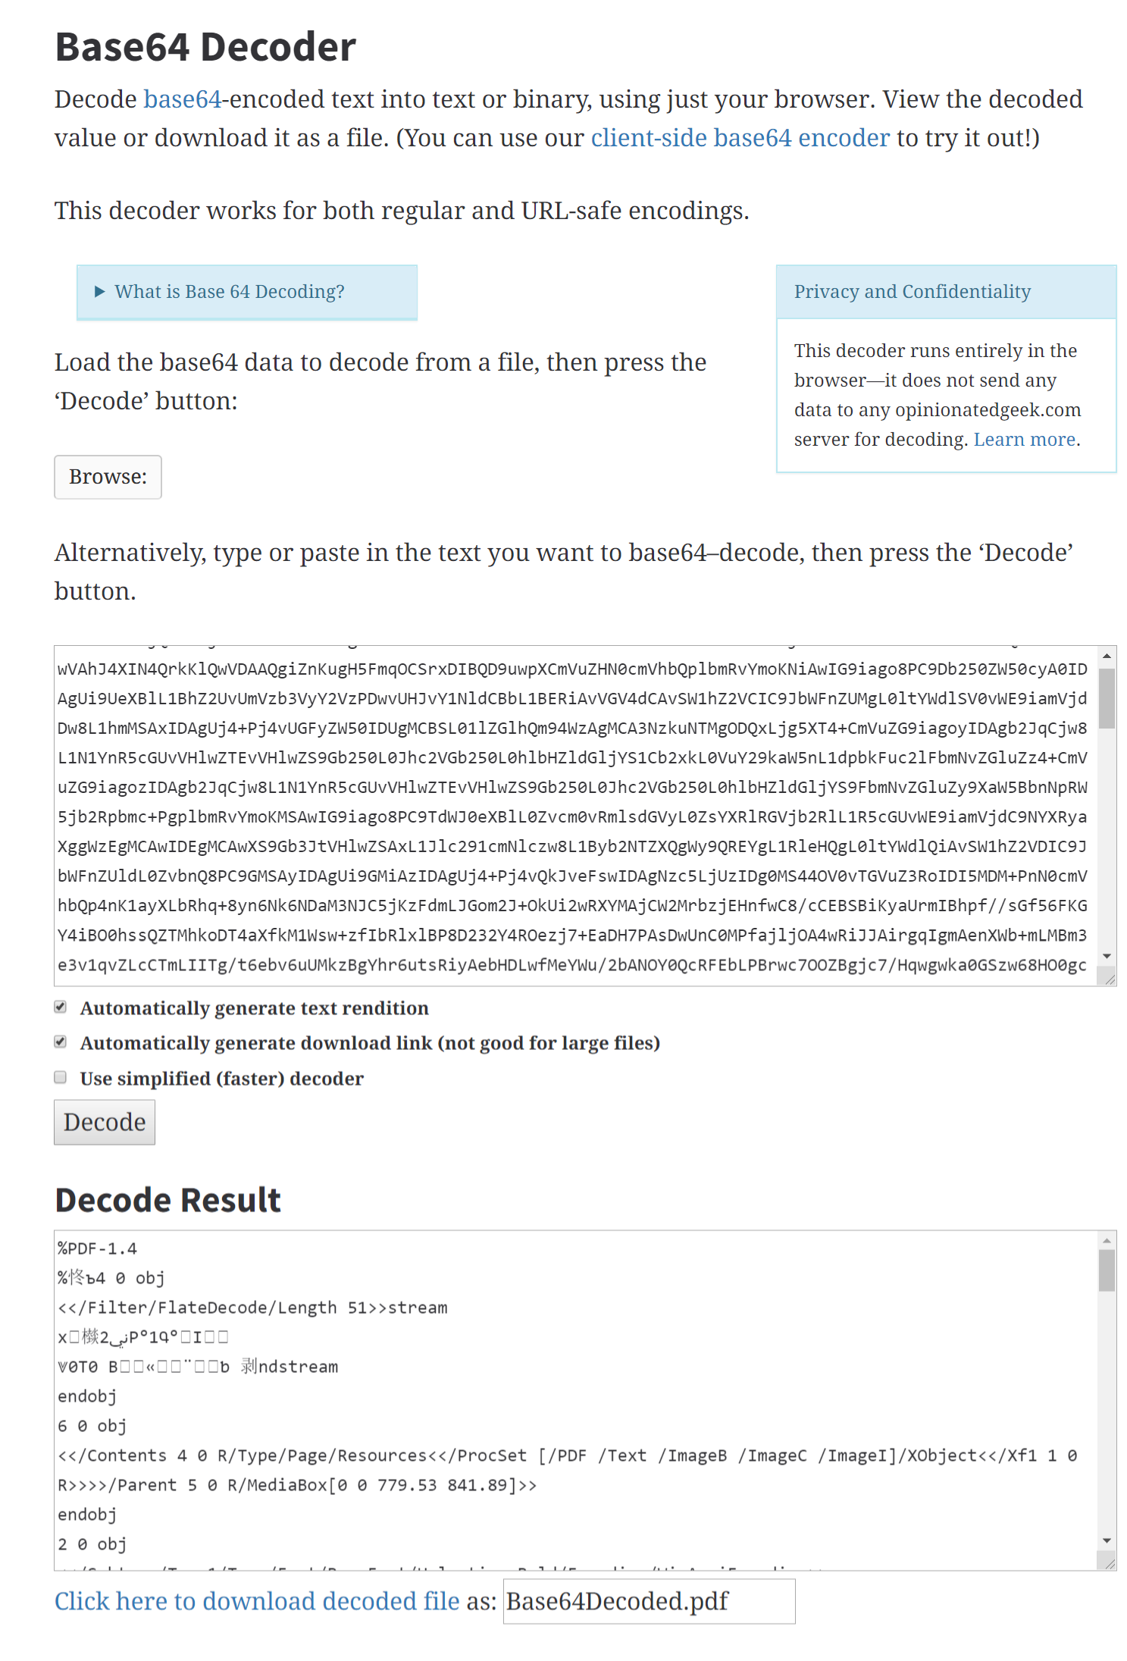

The same webpage also offers a Base64 Encode Option, which you can use in case you need to pass in an image as base64 string, for example a logo.

The encode an image file to a base64 string follow these steps:

1. Select the file to be encoded
2. Press Encode
3. Copy the full text from the text box “Encode Result” and paste it into the appropriate attribute in your request message.

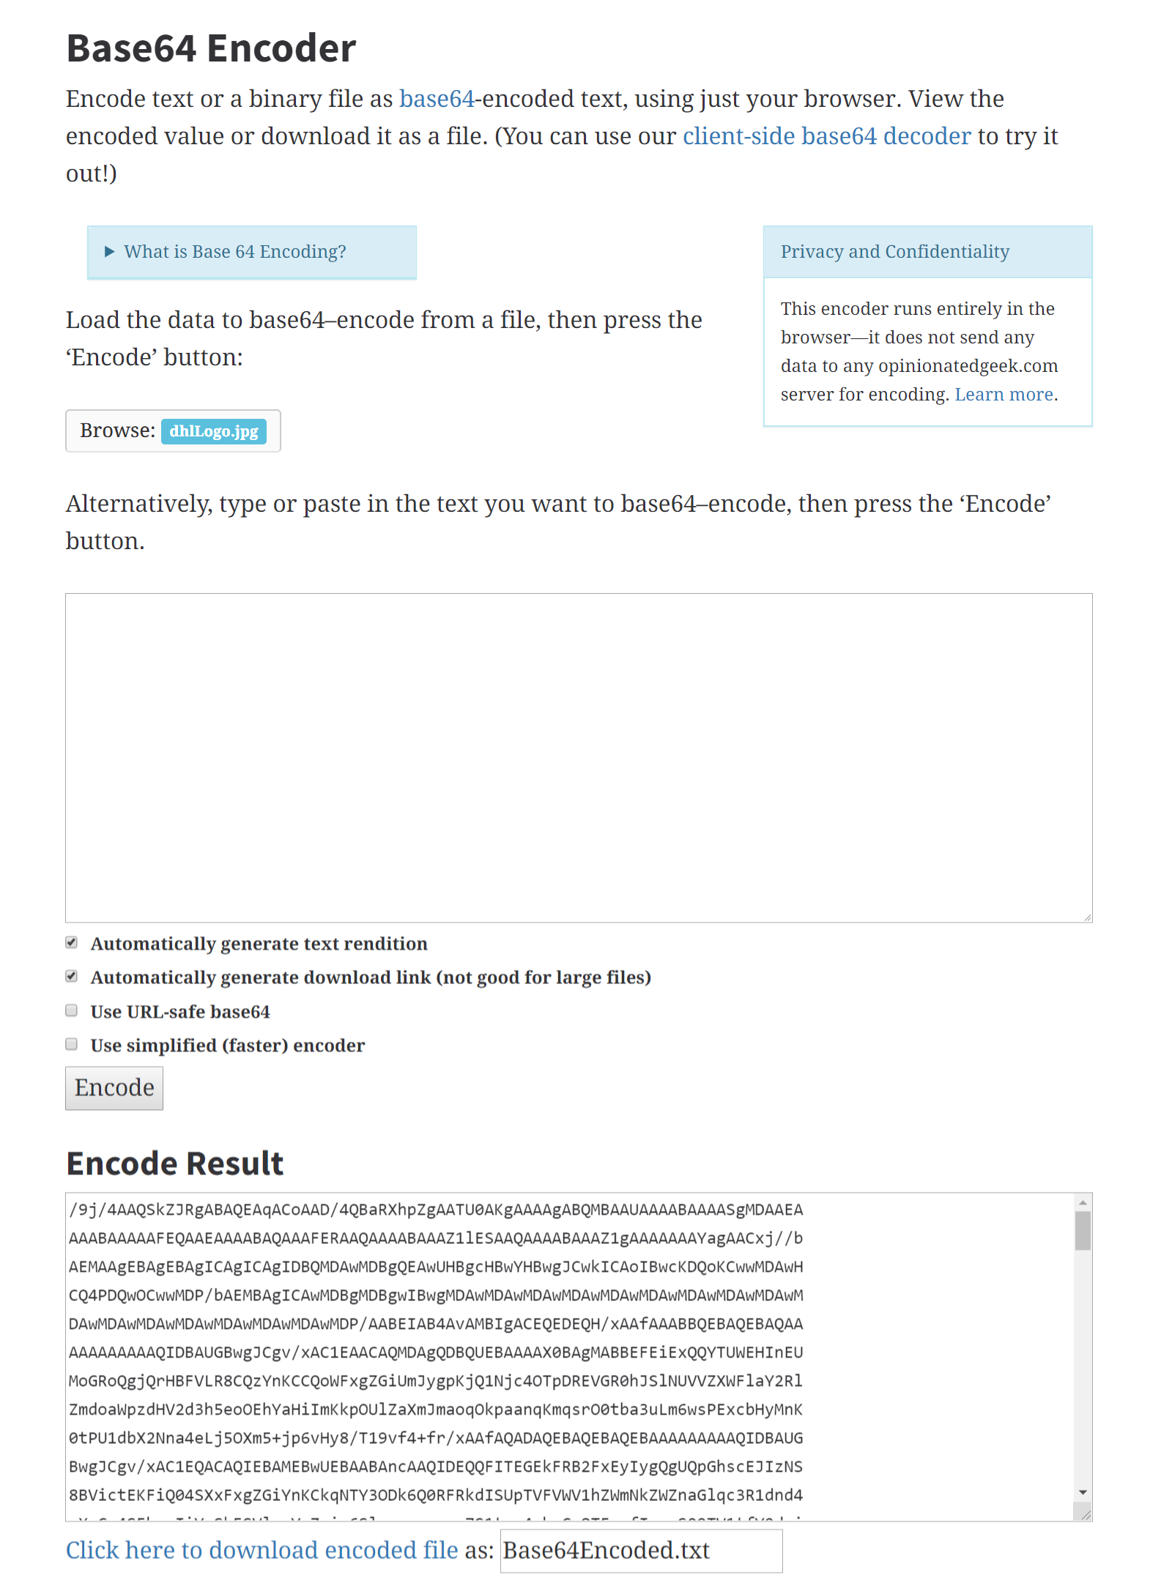

# Appendix G: Testing GLS with SOAP UI

To test the GLS Label creation without developing efforts, you can use common web service testing applications like e.g. SOAP UI.

We will use this tool as an example and show you how to test the creation of a transport label via the DHL GLS service.

1. Download and install SOAP UI from <https://www.soapui.org/downloads/soapui.html>
2. Start the application
3. Press the SOAP Button to create a new SOAP Project
4. Copy the test WSDL from “ Appendix F: Service Endpoints for testing and production” into the field “Initial WSDL” and set the “Project Name” to e.g. “DHL GLS”  
   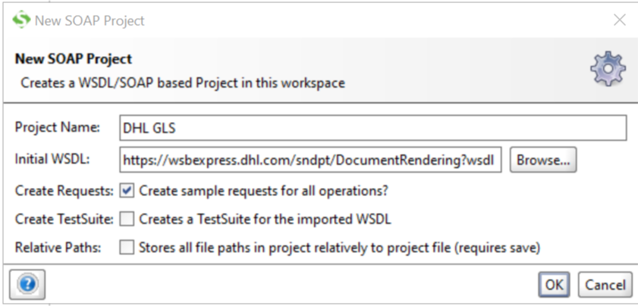
5. A new project has been created with a request message containing all possible attributes.
6. To easily start we copy one of the sample request messages above e.g. the one from “Full Data Lookup”
7. It should look as follows:  
   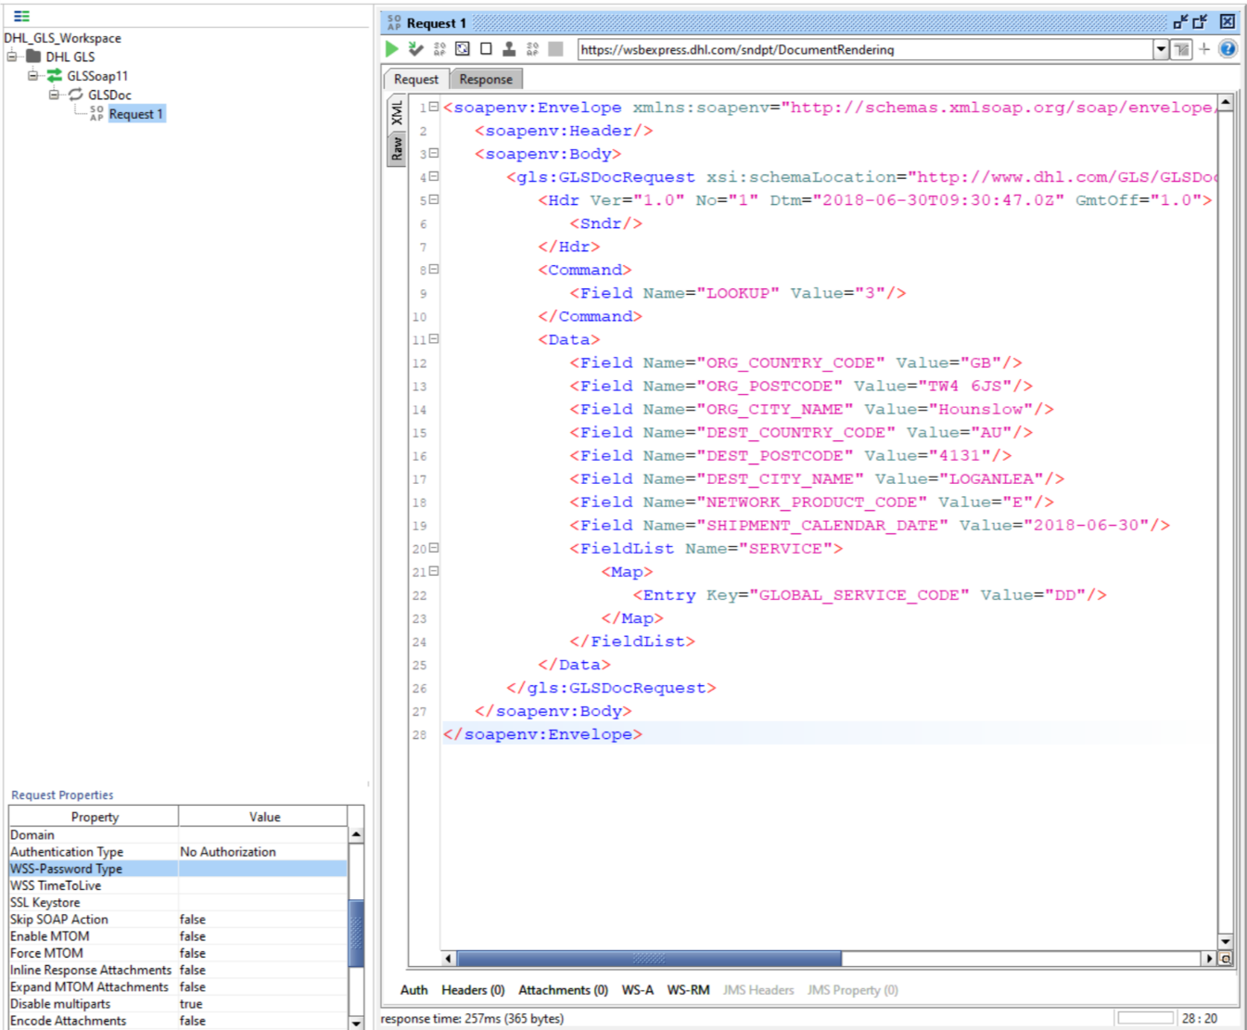
8. If you try to execute the request message via the green triangle on top of the request message, you get an error, that you are not authorized to use the service. Hence we need to enter the credentials we have gotten from your DHL contact.
9. Press the “Auth” button on the lower left corner in the request message window and select “Add New Authorization” from the “Authorization” drop down box.  
   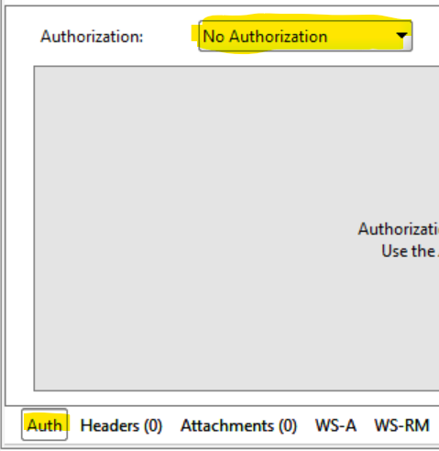
10. Select the type “Basic” from the next dialog and press “OK”  
    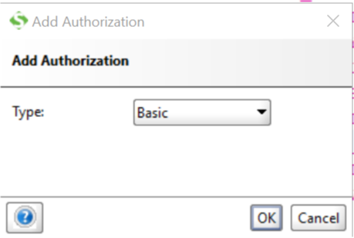
11. Insert the username and password into the appropriate text fields and set the “WSS-Password Type” in the Request Parameters on the left to “PasswordText”.  
    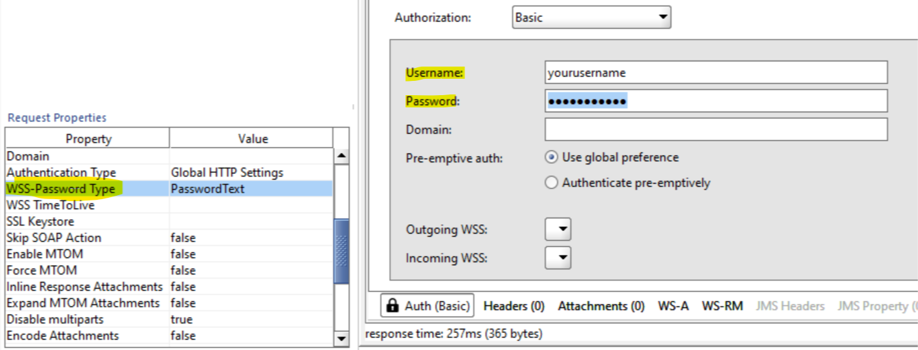
12. Execute the request again via the green triangle. You now should get back a positive response from the service as shown in the screenshot.  
    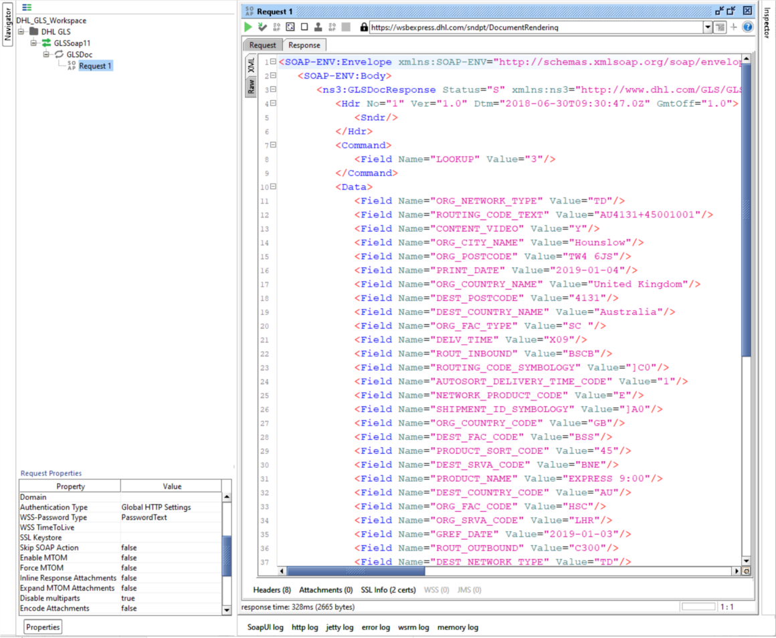
13. Save your project via the “Save All” button in the menu.
14. When you want to add more request messages to you project, just use the right mouse option on the request name and clone the request. This will copy over all the authentication settings you have just done.

# Appendix H: SOAP UI Sample Project

To make it even easier for you, we have prepared a sample SOAP UI project with all the requests from this documentation. You can open the below file simply via the “File/Import Project” Menu option.

Only thing you need to do is exchange the username and password in each of the request messages.



# Appendix I: Helpful XML and Web Service Links

XML.Org Home Page, Organization for the Advancement of Structured Information Standards (OASIS)  
<http://www.xml.org/>

W3 Schools XML Tutorial, Reference Data  
<http://www.w3schools.com/xml/default.asp>

Java Technology and Web Services, Sun Microsystems, Inc.  
<https://www.oracle.com/technetwork/java/javase/tech/webservices-jsp-136868.html>

Apache Web Services Project, The Apache Software Foundation  
<http://ws.apache.org/>

W3 Schools Web Services Tutorial, Reference Data  
<https://www.w3schools.com/xml/xml_services.asp>

Base64 String En- and Decoder  
<https://www.opinionatedgeek.com/Codecs/Base64Decoder>

Regular Expression checker  
<https://regex101.com/>

Various helpful XML Tools  
<https://www.freeformatter.com/xml-validator-xsd.html>

Please be aware that the content of the links above is not provided by DHL.